**How to Enter CEU Credits**

**STEP 1**

Go to the **FRA Website Academy Tab** and click on this link [**https://fra-members.flcities.com/**](https://fra-members.flcities.com/)

**STEP 2**

**Sign in** (Use the login credentials that you use for registering for an event (not the MyFRA system). If you do not have these contact **Merrily Bennett at** [**mbennett@flcities.com**](mailto:mbennett@flcities.com))

**STEP 3**

Once you have signed in click on **Academy Reporting** on the top right of your webpage.

**STEP 4**

Click on [**Enter CEU Credits**](https://fra-members.flcities.com/FRA/CEU_Entry.aspx)

**STEP 5**

Click on the **“+” sign** to the right of the page. (See sample below with highlighted area)

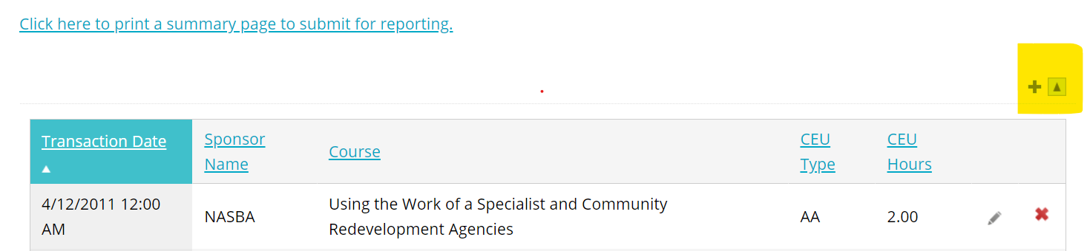

**Explanation:**

**Transaction Date = Date of Course - Use the Calendar Icon**

**Sponsor Name = Entity Sponsoring Course**

**Course = Program/Course Title**

**CEU Type = Conference, Course, etc.**

**CEU Hours = 1 hour equals 1 CEU**

**NOTE:**

* You will not need to enter any credits that you have obtained through FRA. (i.e. Academy Courses or Annual Conference, etc. These will be recorded automatically.)
* You will need to enter any credits obtained by any of our approved education programs**. See approved list in the Program Guidelines document.**
* To obtain a list of your credits click on: [Click here to print a summary page to submit for your reporting use.](https://fra-members.flcities.com/FRA/CEU_Search.aspx)
* If you need to print your list use control-P keys on your keyboard. If you need a PDF version look at your available printers and choose print-to-pdf option.