100 Word Description of the Entry for inclusion in the Best Book

Historic preservation of the 1927 Hacienda Hotel captures a sense of place in downtown New Port Richey. This destination for tourists and locals provides 40 unique rooms with a Spanish-Floridian charm and historic markers along the sidewalk adding cultural heritage and charming views of the park and downtown.

Bringing back to life high quality design standards and attractive architectural features enhance this primary gateway to the city with adaptive reuse and beatification. Stimulating the local economy, the Hacienda Hotel is a catalyst to the downtown businesses, expanding the market, and establishing new synergies.

Innovation-How the project used new ideas to solve problems or carry out the project or program

Our plan is to move New Port Richey forward while maintaining and emphasizing the city’s unique history and culture. What does the loss of a historical building mean? It is a loss of place, of cultural heritage and the defining characteristics of the community. The blighted building in 2007 was in decay because the building was empty and vandalism occurred on a weekly basis. The building was becoming a financial burden, but without the repairs the historic architecture of the building would have been lost. The Hacienda Hotel is a paddle away from the Pithlachascotee River and activating the hotel will draw more people into Sims Park and reduce crime and blight.

In 2009, the feasibility report provided a list of hotels considered competitors. On the list was the Lakeside Inn in Mount Dora, Florida, who ultimately became our partner in the renovation of the Hacienda Hotel. A Private-Public Partnership with the owners of the Lakeside Inn in Mount Dora restored the building, adding historical markers on the sidewalk to pay respect to the people of significance who once enjoyed the Hacienda Hotel and the New Port Richey area. The ability to not only market New Port Richey, but also Mount Dora provides additional attractions for both locations and benefits both communities in Florida.

Without the funding resources of the C.R.A. and the grants received with the help of State Senate President Wilton Simpson the building would have been too costly for any private investors to consider. Working with Mr. Gunderson from the Lakeside Inn and his appreciation of the history of the building made the public-private partnership strong.

In New Port Richey there are several examples of Mediterranean Revival style buildings, ranging from commercial structures to large villas. All of these were built during the Florida Land Boom of the 1920’s and are representative of Florida’s rapid growth and frenetic activity during this period. Among these, the Hacienda Hotel is significant because it reflects use of typical Mediterranean Revival style features for a hotel. Defining features include two large wings that form a courtyard, mullet stucco wall surfaces, loggias, wrought iron, arched windows and doors, and balconies. The building is the largest example of the use of the Mediterranean Revival style in New Port Richey. Although the building has undergone some modifications, the building continues to display its original architectural integrity, feeling and historic association, and is a historic landmark. In addition, it is the work of Thomas Reed Martin, recognized as one of the most important Florida architects from 1920 until the 1950’s. We needed a partner who could appreciate the historic value, had experience as an hotelier, and understood the cultural significance of the building to the community.

Community Impact

Historical background will help to understand the community impact. In 1925, plans were put in place to construct a 100 room hotel at an estimated $150,000. The land was donated by James Meighan, with the condition no more than 60 rooms. The Civitan Club raised funds for the original construction. In February of 1927, the formal opening hosted by City Club of New Port Richey with 120 guests.

The Hacienda Hotel is a prominent local landmark and has returned to being a destination for tourist to take a picture and for locals to walk past with pride and shop in the historic New Port Richey downtown and enjoy the beauty and recently renovated Sims Park. The Hacienda Hotel history was as a hub for New Port Richey’s celebrations. The increased foot traffic will benefit the sales of the local retail shops and restaurants. The restaurant in the lobby area has views of the park. Sims Park is full of beautiful scenery along the Pithlachascotee River (locals call the Cotee River) which leads into the Gulf of Mexico. You can launch your boat, kayak, or walk downtown for a meal. The park includes walking trails around Orange Lake, splash pad and playground equipment, as well as an amphitheater and all are just steps from the lobby of the Hacienda Hotel.

The strategic decision by the city was to move the economic engine of the downtown. What once attracted vandalism now is a destination point and serves as a catalyst for the downtown businesses and those who want to enjoy the park and the river and all of the natural beauty surrounding the Hacienda Hotel. New synergy has been established with the local realtors to bring in new businesses. The City of New Port Richey will be able to generate revenue by obtaining the highest sustainable land value possible to recapture the cost of the initial investment over time. Ownership of the building will be back in the hands of the private sector and used for its original purpose as a hotel and destination attraction for New Port Richey.

Anticipating foot traffic across the bridge from travelers staying at the Hacienda Hotel a number of businesses have been attracted to the downtown revitalization and see the hotel as a key selling point.

The biggest impact is the surrounding area that once had vacant commercial spaces, is now filled with independent and local ownership, unique to New Port Richey and additional housing was always part of the strategy and hope that the historical structure has been able to attract to the area providing additional foot traffic to the area.

Funding- How the project leveraged funding and in-kind assistance

To provide context for the need for funding the state of the building is important to understand. For 60 years the hotel operated until the purchase by Gulf Coast Jewish Services in 1985. The building became Florida’s first “house for special services” providing housing for the elderly and supportive services. For ten years, it sat vacant and the lack of maintenance was evident and the city began the process of creating a redevelopment plan.

The building was purchased by the CRA in August of 2003, for $2,200,000.00 and was leased back until all the residents were able to be relocated to other facilities. In 2006, an agreement with Community Development Partners began, but by 2012 the relationship was abandoned. The project came to a halt. The C.R.A. had the daunting task of finding new partners, work on the upkeep of the building which had a lot of pressure from the community to save it from decay. A breakdown of some of the grants awarded are as follows:

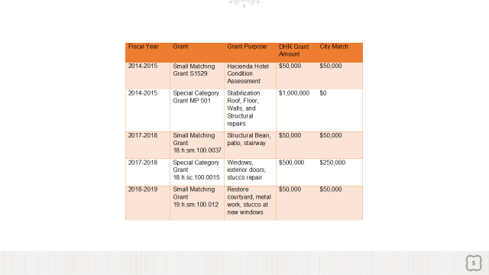

As you can see in the table, Three Florida Historic Preservation Small Matching Grants $50,000 each were awarded for a total of $150,000. Two special category Grants were awarded $500,000 and $1,000,000.00 which was allocated without match funds requirements with the support of State Senate Wilton Simpson. The C.R.A. match for all five grants was $400,000.00 for a total of $2,050,000.00 of grant funds. Small Grant Funds were used to restore window and floor damage from water intrusion and the biggest expense for the C.R.A. was to put back the beautiful tile roof. The city owned building was appraised in 2014 for $500,000 “as is”. Atelier Architecture completed the historic condition assessment and Bender & Associates completed the $1,000,000.00 stabilization grant that included the removal of non-conforming addition and a new, historically accurate roof that complies with current hurricane codes. In 2017, the estimated project budget listed structural beam in the dining room archway, historic scored patio restoration, floors, grading ingress/egress point/ internal historic stairway, and professional services. The exterior of the building has been restored in keeping with its historic architecture.

The building was sold for $800,000 with the expectation that an additional $4,000,000.00 in restoration is anticipated for the developer in order to obtain occupancy The purchase agreement required a date of Certificate of Occupancy issued and on the anniversary date to make payments as follows:

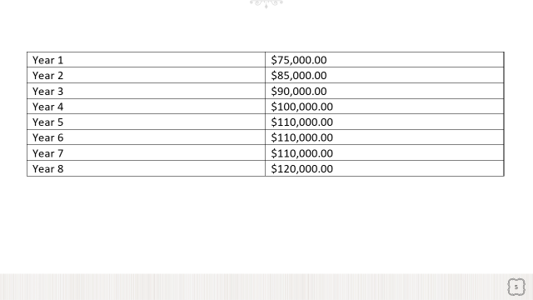

The building and the property can be enjoyed by the public once again.

Problem Solving-How the project used problem-solving to address unique local issues.

To lead the downtown forward required a strategy centered on the revitalization and reuse of the Hacienda Hotel as a vital component. Sims Park and Orange Lake are a place for families now. A shell of a building abandoned in the Palm District was completed and added additional commercial space and multi-family housing.

Additional parking needed to be solved. There are 13 surface parking spaces on site. The City has provided space in the public parking lot across the street, the updated surface parking lot cost was $1 million. The City has also built a $6.5 million parking garage in 2021 offering free electric shuttles for employees, guests, and other patrons of the downtown district. The parking garage was built on property donated to the CRA by the developers of the Keiser University. an additional 350 public parking spaces in the garage are now available for public use and use by the University. The entrance into the city is beginning to take shape and become more inviting to visit.

While the Hacienda Hotel property was owned by the city it was not providing any taxable value. The renovation and restoring the reuse back to its original purpose, the historical significance of the building is a welcome site near downtown and the Sims Park and Pithlachascotee River. It is a gateway to New Port Richey and attracts additional retail to the downtown area. The C.R.A. will begin to receive taxable value from the property in year one.

The original expansion plans were changed due to cost and the loss of meeting room space needed to be addressed. The city has given additional space in the historic Peace Hall inside Sims Park for hosting events such as weddings for use by the Hacienda Hotel. The Peace Hall also has historical significance and makes it a lovely place to host weddings and private gatherings. The Hacienda Hotel will be able to package both locations and increase the use of each.

Applicability to Other Communities- Why this project or program could be transferred to other communities

There are a few ways other communities could apply what we learned in the process of the project. Identify partners from other communities looking to expand helps to support both communities. You can market both locations, create stability for the business by diversifying and expanding market share.

Recognize the continued maintenance costs and determine how to decrease expenditures and increase taxable value. The solution is to get the project developed and back as an asset to the community and remain steadfast in the importance and significance to the community to restore and reuse existing buildings.

We also tied in other projects and looked at the area of the Hacienda Hotel as the impetus to update Sims Park and create more retail space and multi- family in the area. Create a family friendly activity center for visitors and residents with access to parking, education, and events.

The Hacienda Hotel was a vital component to the synergy that has led to the revitalization of the downtown. It has moved forward projects that were abandoned and brought back to life adding more retail space which then allowed for higher end apartments and changing the use of Sims Park to be more family friendly.

Other things to tell the judges: Description or video (provide link) of any other aspects (first of its kind, most successful, aspects not included above)

[Florida's hidden gems: The Hacienda Hotel in New Port Richey - Bing video](https://www.bing.com/videos/search?q=hacienda+hotel+youtube&view=detail&mid=4135894131069351452A4135894131069351452A&FORM=VIRE)

