**3CMA Awards – 50th Anniversary Celebration**

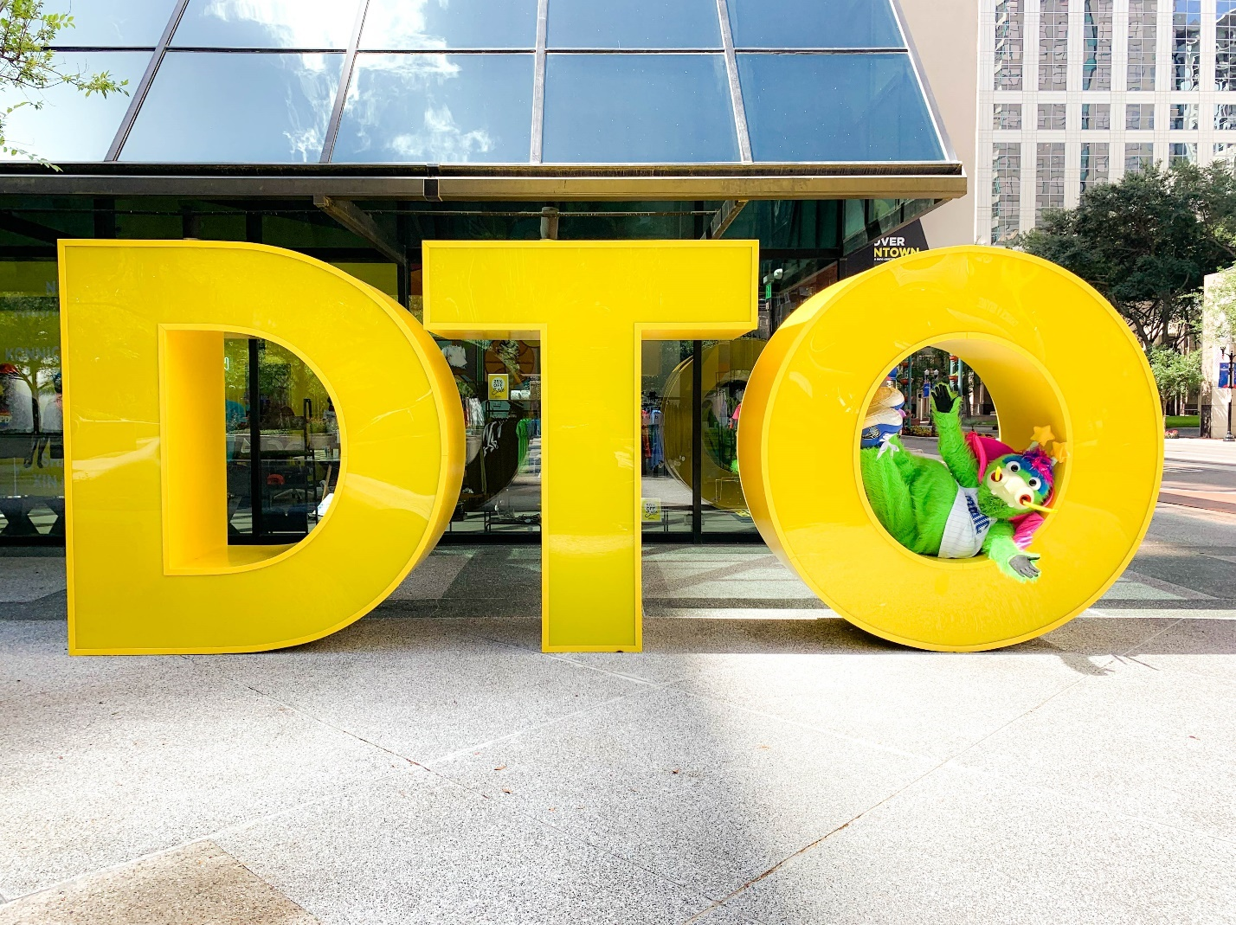**DTO Sculpture Reveal**

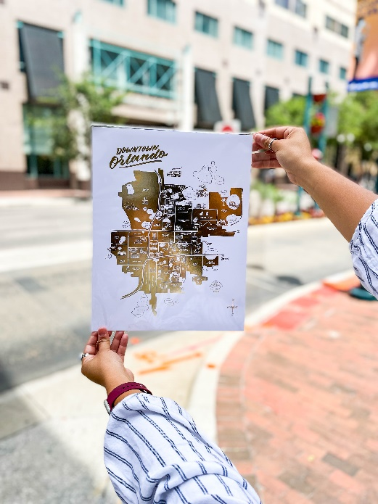On the day of the DTO Sculpture Reveal, we received 62,743 impressions and 5,192 engagements on Facebook, Twitter, and Instagram. We invited Orlando Magic mascot, Stuff the Magic Dragon, to stop by and take photos in front of the DTO. These posts were shared on the Orlando Magic and Stuff the Magic Dragon social platforms resulting in 21,308 impressions on Facebook, Twitter, and Instagram.

**50th Anniversary Merchandise**

The Discover Downtown Facebook shop launched just in time for the 50th anniversary. In 2021, we received 5,405 views on the Facebook and Instagram store. The most popular 50th anniversary item on the Instagram and Facebook store was the limited-edition gold downtown Orlando map. On May 21, Discover Downtown had a 50% off sale. Our audience was extremely excited about the sale, the posts on Facebook, Twitter, and Instagram received 19,963 impressions and 901 engagements.

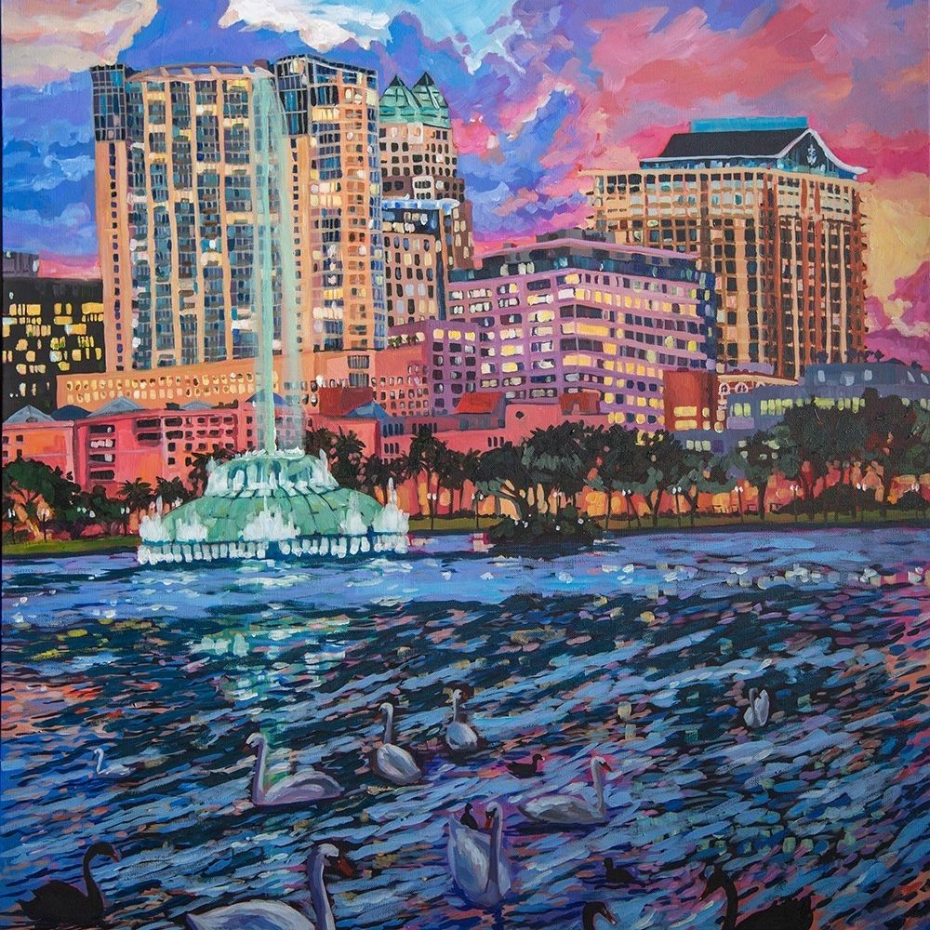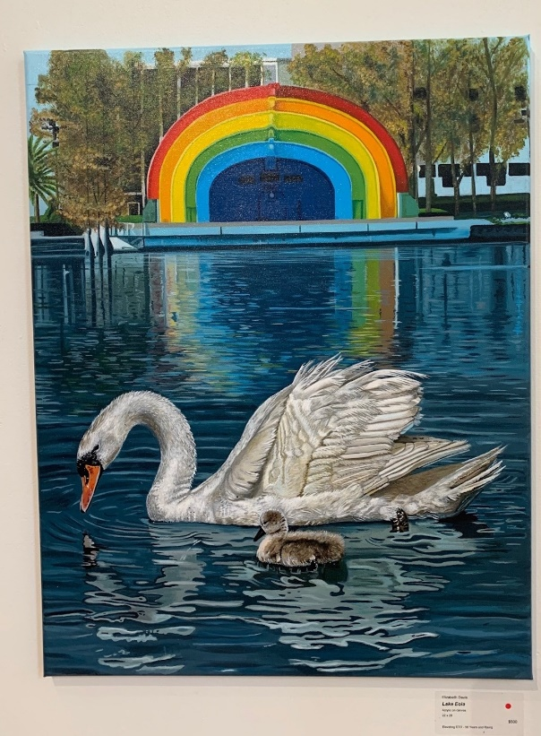

**Elevating DTO, 50 Years and Rising CityArts Gallery**

While CityArts was hosting the Elevating DTO, 50 Years and Rising, gallery we received 14,979 impressions and 221 engagements from posts about the gallery. We posted an Instagram Reel showing a sneak peek of the gallery, which received 3,448 views and multiple comments expressing interest about CityArts and the gallery.

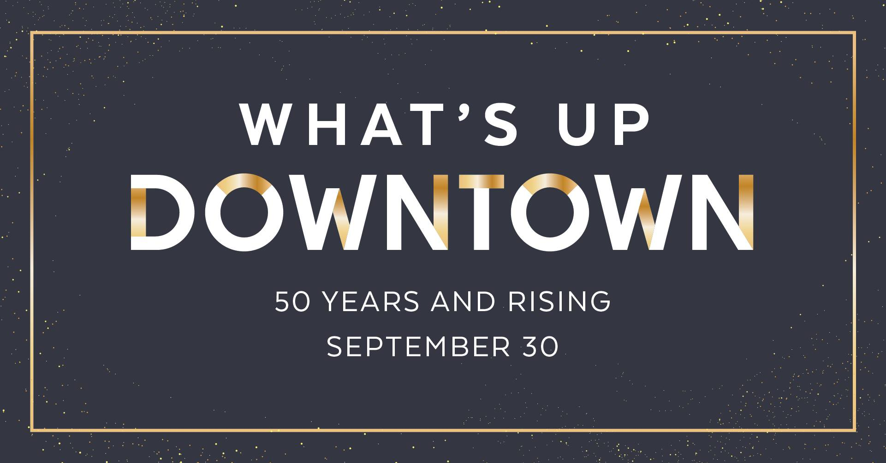

**What’s Up Downtown- 50 Years and Rising**

For What’s Up Downtown – 50 Years and Rising, we started promoting the event on Facebook and Twitter 2 weeks prior to the event. Over those 2 weeks, we received 8,467 impressions and 76 engagements.

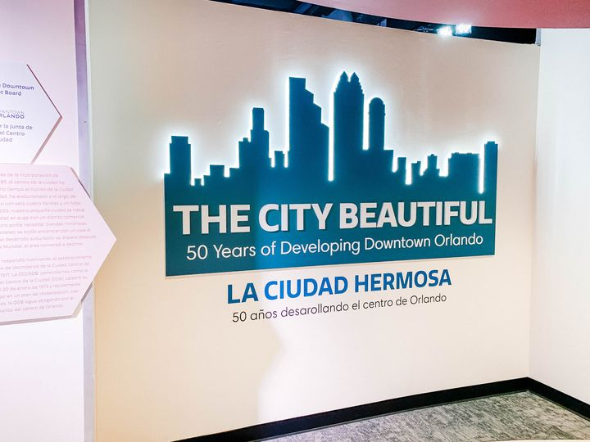**History Center Exhibit**

Every 2 weeks we promoted The City Beautiful – 50 Years of Developing Downtown Orlando exhibit on Facebook, Twitter, and Instagram. We posted about the exhibit 18 times on social media and these posts received 417 engagements and 17,129 impressions.