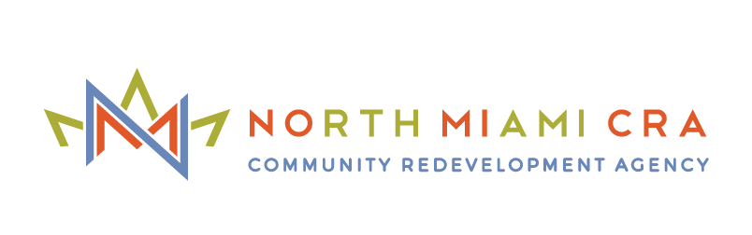

**NORTH MIAMI COMMUNITY REDEVELOPMENT AGENCY (NMCRA) TO GIVE $1,000,000 TO NORTH MIAMI RESIDENTS FOR RENT RELIEF**

*NMCRA Board Approves New Residential Aid Program and an Additional $600,000 for the Jump Start Businesses Grant*

**NORTH MIAMI, FL.** – (May 12, 2020) – To provide necessary funding to residents and businesses during the ongoing COVID-19 crisis, the North Miami Community Redevelopment Agency (NMCRA) Board today approved unanimously a **New Renters Assistance Program**, which will distribute $1,000,000 to qualified North Miami residents to cover up to two months’ rent. [**Only residents within the North Miami CRA boundaries**](https://arcg.is/1eTPem) **can apply and must submit applications no later than May 29th at 2 p.m. to be considered. Online applications are available via email** [**cragrants@northmiamifl.gov**](mailto:cragrants@northmiamifl.gov) **and paper applications are available for pick-up at the Joe Celestin Center in North Miami.** The Board also approved additional funding for another 120 businesses (240 total) to receive the **Emergency Relief to Jump Start Businesses**, a program providing grants up to $5,000 to businesses within the North Miami CRA to revitalize their operations once the emergency declaration has been lifted.

First, the North Miami CRA created the $1,000,000 **New Renters Assistance Program** to cover up to two months’ rent for qualified residents [**within the NMCRA boundaries**](https://arcg.is/1eTPem) who cannot afford to pay due to circumstances related to the coronavirus pandemic. Applicants must reside in the city for one calendar year, show proof of negative impact by COVID-19 by loss of job or benefits, and provide the landlord’s contact information since the payment will be made to them directly. **To request an online application, interested parties should email** [**cragrants@northmiamifl.gov**](mailto:cragrants@northmiamifl.gov)**. Paper applications will be available for pick-up** starting **Wednesday, May 13th, at 9:00 a.m. at the Joe Celestin Center** (1525 NW 135th Street, North Miami, FL). **Due to the high volume of interest, applicants will be chosen at random based on a lottery-style selection.**

“During this time of crisis, the North Miami CRA is working tirelessly to offer both residents and businesses alike a reprieve on their financial burdens while they wait for other benefits to materialize,” says North Miami Mayor Philippe Bien-Aime, Chairman of the North Miami CRA Board. “We also understand that small businesses are the backbone of a thriving economy, so providing additional funding for our emergency commercial aid programs will allow even more North Miami businesses to be prepared for a quick recovery when the time comes.”

In addition to the New Renters Assistance Program, the NMCRA Board also approved another $600,000 in funding for an additional 120 businesses (240 total) to receive the **Emergency Relief to Jump Start Businesses.** This one-time grant provides up to $5,000 to **businesses** [**only within the North Miami CRA boundaries**](https://arcg.is/1eTPem)for future operational expenses, including: rent, payroll, communications, utilities, etc. Funds will come into effect once the disaster declaration has been lifted, but small businesses can apply for the loan immediately at <https://portal.benevate.com/northmiami/participant>. Candidates **must have been denied** for the [U.S. Small Business Administration (SBA) Disaster Loan](http://sba.gov/) and [Florida Disaster Loan](https://floridadisasterloan.org/) programs. It is necessary for applicants to provide documentation of the application with receipt.

The NMCRA previously awarded 50 North Miami businesses with grants up to $1,000 through the **Emergency Relief for Essential Businesses Program.** This funding is helping existing small businesses deemed essential by Miami-Dade County and the City of North Miami Offices of Emergency Management to continue limited operations during the public health emergency.

For applicants to see if they are located within the North Miami CRA and are eligible to apply, click link: [https://arcg.is/1eTPem](https://nam03.safelinks.protection.outlook.com/?url=https%3A%2F%2Farcg.is%2F1eTPem&data=02%7C01%7CBrian.Kingery%40timmons.com%7C29562bec59834b8cb0a208d7f2b3fef0%7Cad6f659bc6ac4bfa81e28c8fa7c5fca4%7C0%7C0%7C637244727216541375&sdata=kVR2SUn8bQFRlQKYEp30WiQcVkNSzKG2lSPbDr4PUMg%3D&reserved=0). Businesses interested in any of the NMCRA relief programs, should contact [cragrants@northmiamifl.gov](mailto:cragrants@northmiamifl.gov) or 305-895-9839 to receive instructions on how to complete the applications.

###

*For media inquiries, please contact Taylor Cavazos at Kivvit at* [tcavazos@kivvit.com](mailto:tcavazos@kivvit.com) *or 956.245.6788.*

**About the North Miami Community Redevelopment Agency (NMCRA):**

The North Miami Community Redevelopment Agency is an independent government agency tasked with eliminating slum and blight in the heart of downtown North Miami. The NMCRA does this by using increases in taxable values to transform the area into one that again contributes to the overall health of the community.  This transformation occurs through various grants and incentives initiatives including: Commercial Rehabilitation and Beautification Grants; Public Private Partnership Developments; Infrastructure Improvements; Neighborhood Improvement Programs; Affordable, Workforce, Market Rate, Luxury and Mixed Income Housing; Affordable/Workforce Housing Development & Renovation; Transportation and Transit Developments.