Complete the form below to submit your entry.

NOTE: The system at this time does not allow you to save your entries, get out of the system and go back in. You have to upload everything at once.

**AWARD CATEGORY (Select one)\***

Annual Reports

Capital Project/Infrastructure

Creative Organization Development and Funding

Cultural Enhancement

Fiscal Impact Study

X Management Programs Creative Partnerships

Out of the Box

Outstanding Housing Project

Outstanding New Building Project

Outstanding Rehabilitation Renovation or Reuse Project

Planning Studies

Transportation Transit Enhancement

**SUBMITTING MEMBER ORGANIZATION\***

Redevelopment Management Associates, LLC (RMA)

**PROJECT TITLE\***

Deltona Strategic Economic Development Plan & Implementation

**We qualify as a Small Project / Program entry.\*** In addition to our submission being considered under one of the above categories, our entry qualifies to be considered for another award, as the best of all submitted Small Project/Program entries, over all categories, for jurisdictions under 25,000 population.

Yes

X No

**CONTACT NAME & TITLE\*** (This name will appear in the Best Book if you win)

Lynn Dehlinger, Senior Economic Development Manager & Associate Broker

**CONTACT EMAIL ADDRESS\*** (This email will appear in the Best Book if you win)

lynn@rma.us.com

**ADDRESS\***

2302 E. Atlantic Blvd.

Pompano Beach, FL 33062

**PHONE NUMBER\***

954-695-0754

**Who were your private sector or non-profit partners? Please be as specific as possible.\***

Private: DOT Properties, a property owner headquartered in Australia; Seefried Industrial Properties, the developer for Amazon

Public: City of Deltona Economic Development Office, Duke Energy, Department of Economic Opportunity, Career Source, and Team Volusia

**Award Entry Details**

**Project Main Image\***

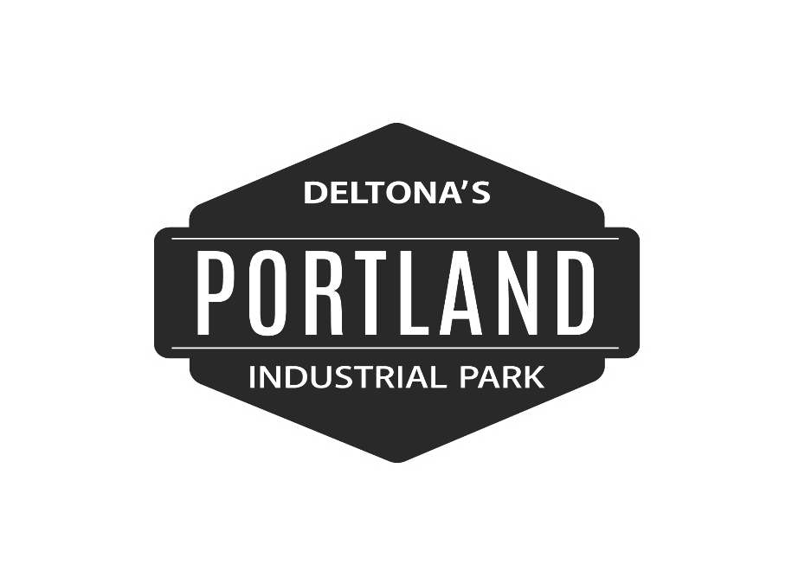

Maximum allowed: 32MB

**100-word Description of the Entry - for inclusion in the Best Book\***

The City of Deltona hired Redevelopment Management Associates (RMA) to create a Strategic Economic Development Plan for a business park and manufacturing related recruitment. An economic development approach with a real estate-based foundation was used to develop a plan for an Innovation District, Logistics and Commerce Centers on 240 acres near Central Florida’s transportation corridor. RMA also helped implement the plan by attracting Deltona’s Portland Industrial Park developer that brought Amazon as an anchor tenant. This development will provide 500 full-time jobs with an average annual payroll over $16 million and deliver a $100 million project to the tax base.

**Innovation - How the project used new ideas to solve problems or to carry out the project or program\*** 0 of 100000 max characters

In August 2018, the City of Deltona hired Redevelopment Management Associates (RMA) to develop a Strategic 5-Year Economic Development Plan for a Business Park and Manufacturing Related Recruitment. Deltona, located midway between the cities of Orlando and Daytona Beach, had large areas of vacant land off Interstate-4 (I-4), Central Florida’s main transportation corridor. A 240+/- acre area of vacant land was one of the last high-traffic locations along I-4 to yet be developed. The city had gathered data prior and determined new targeted industry sectors it wanted to recruit: Manufacturing and Logistics. RMA’s team of professionals took an economic development approach with a real estate-based foundation to develop the Strategic 5-year Economic Development Plan for the City of Deltona by conducting in-depth research. In their research, RMA had found the following:

* Deltona is 61 miles from Port Canaveral, soon to be designated a commercial freight port in addition to its well-known cruise ship designation
* There was already the beginning of a medical cluster across from the 240 +/- acres of vacant land as well as plans for a retail village on adjacent land
* The City already had many educational institutions that were offering courses related to manufacturing

RMA used this data as building blocks to create an economic development plan that would capitalize on the city’s assets. It was determined that the 240+/- acres area off of I-4 was determined to be the best location for the development of a Business Park and recommended three phases of development with potential uses of: institutional, headquarters, start-up, tech transfer offices, distribution, research facilities, light manufacturing, and affordable workspaces. The 3 phases included an Innovation District, Logistics Center, and a Commerce Center. In April 2019, RMA completed Deltona’s Strategic 5-Year Economic Development Plan that provided strategies and recommendations based on data, research, and analysis. RMA had created a plan that could be implemented, as was evidenced by what happened next.

During the development of the plan, RMA had contacted and set up a series of meetings with the property owner of the large 240+/- acre site, which was a privately-owned investment group out of Australia that had held these properties for more than 40 years. RMA was able to convince the property owner that the parcels should be developed as recommended in the Strategic 5-Year Economic Development Plan. In January 2019, RMA was hired by the property owner to find a suitable development partner/buyer for the property.

Through RMA’s extensive real estate connections, a developer was located, interviewed, and selected to develop the first phase of what will be known as Portland Industrial Park. RMA’s branding services were also utilized to create the logo for the new industrial park. In May 2019, RMA brokered the deal between DOT Properties headquartered in Australia and Seefried Industrial Properties, the developer for Amazon. RMA also helped the developer receive approval from the City for a $2.4 million incentive linked to full-time jobs.

The hard work paid off though when the City welcomed the anchor tenant for Deltona’s Portland Industrial Park… Amazon. A 1.4 million square foot Amazon fulfillment center is being constructed on an 85-acre portion of the new Portland Industrial Park. The project is well underway and scheduled for building completion December 2020. RMA created an implementable Strategic Economic Development Plan and then worked that plan to execute their international deal-making services in securing an Amazon distribution center as the anchor for Deltona.

Problems solved included environmental issues with state and federal wildlife agencies, the tenant’s aggressive timeline that threatened to kill the project if permitting was not approved according to their schedule, and transportation incentives were needed to make the project feasible from the development standpoint. RMA served as the project manager to navigate these problems and utilized partnerships with the many municipal and state agencies needed to help with these issues.

**Community Impact – How the project improved economic, social, design, cultural assets of the community\***

In RMA’s research on the City of Deltona, it was found that of the approximately 35,000 labor workforce in Deltona, about 33,000 were leaving the area for employment. Deltona’s Portland Industrial Park will work to add jobs for residents so they can find employment in the city, especially since the city has worked hard to provide educational opportunities focused on manufacturing. The new development anticipates major positive economic development for the community including:

* $100 million project will be added to the tax base
* 500 full-time jobs will be added by 2022 plus seasonal jobs
* $16+ million average annual payroll plus benefits will be paid
* Substantial overall tax revenue increase for the city

The developer will also be constructing roadway improvement adjacent to the site. The national press coverage of this deal promoted Deltona as open for business, as well as renewed a sense of pride in the community with elected officials praising the addition of Amazon as a tenant in Deltona’s Portland Industrial Park. Jerry Mayes, the City’s Economic Development Manager commented, “We were confident that RMA would create the strategies and relationships necessary to achieve the development of a business park and manufacturing related recruitment. However, what they accomplished in such a short time span is truly remarkable and will spur additional commercial growth in the City. We are very proud of this partnership, and we look forward to more successful ventures to come.”

**Funding – How the project leveraged funding and in-kind assistance\*** 0 of 100000 max characters

The City of Deltona had in place a variety of incentives to encourage new investment and projects that support economic development goals. Although the City did not own property in the area the business park was recommended to be located, they leveraged their incentives to attract private development. RMA helped the developer receive approval for a $2.4 million incentive from the city linked to full-time jobs. The developer anticipates that Deltona’s Portland Industrial Park will invest $100 million on the project though, which will go on record as one of the most high-profile projects in the city’s history.

**Problem Solving – How the project used problem-solving to address unique local issues\*** 0 of 100000 max characters

In order to develop a Strategic Economic Development Plan for Deltona that could be implemented, RMA conducted in-depth research on the following:

* SWOT (Strengths, Weaknesses, Opportunities, Threats)
* Available sites
* Stakeholder Input
* Local developments
* Investment drivers: Land, Labor, Capital, Markets, and Regulation

In its research, RMA had found that although the city had an abundance of vacant land that was ripe for development, especially the 240+/- acres off the I-4 exit, the City had not been successful in getting the property owner to the table to discuss development. RMA decided it needed to reach out to the property owner of the 240+/- acres site to see if they would be open to development of their parcels. This was a challenge as the property owner was based in Australia, and seemingly unmotivated as they had held the property for over 40+ years. To help the property owner understand the economic development plan for the area, RMA set up a series of meetings with the property owners over the phone and in-person whenever the owner was available. RMA was able to convince the property owner that the parcels should be developed as recommended in the Strategic 5-Year Economic Development Plan. An agreement was reached with the owners, and RMA was hired to find a suitable development partner/buyer for the property.

Even after RMA was able to find a reputable logistics developer through its extensive real estate connections, there were a number of issues that had to be addressed. As RMA had indicated in the Strategic Economic Development Plan, in order to make this a “shovel-ready” site, certain steps needed to be initiated:

* Although the zoning was compatible for industrial development, needed to change the Activity Center Overlay to allow for the recommended uses
* Environmental studies completed including scrub jay mitigation
* Extend natural gas line

When the developer came onboard, they also needed a very compressed time frame to get the property approved for site development. There were environmental issues, rezoning, easements to be negotiated, and billboard contracts to nullify. RMA and the developer worked closely with the City of Deltona to address these obstacles. Because of the cooperation with the City, all of this was done in a 10-month time frame, from start to site plan approval in December 2019.

Many agencies were needed to achieve a success like this and the partners in this project included the City of Deltona Economic Development Office, Duke Energy, Department of Economic Opportunity, Career Source, and Team Volusia.

**Applicability to Other Communities – Why this project or program could be transferred to other communities\***

0 of 100000 max characters

Although not all cities may be able to attract Amazon, there are some steps that other communities can take to put themselves in the position for development:

* Take inventory of large areas of vacant land, especially near major transportation corridors
* Determine what needs to be done to make available sites “shovel-ready”
* Keep in regular contact with major property owners
* Work with private and public partners to solve issues
* Hire a consultant that has experience working with the private sector as cities may not have the economic development and real estate skills necessary to bring a private partner to the table
* Even if a city does not have site control, they can leverage incentives or other funding for infrastructure to court developers

**Other Things to Tell the Judges – A description or video (provide link) of any other aspects (first of its kind, most successful, aspects not included above)\***

0 of 100000 max characters

The Strategic Economic Development Plan and attraction of Amazon changed the perception of the city as evidenced by press coverage and renewed pride exhibited by the city.

https://deltonameansbusiness.com/portland-industrial-park/

<https://youtu.be/DJpWFLB-bVA>

<https://www.usatoday.com/story/money/business/2019/12/26/amazons-new-distribution-center-bring-500-jobs-deltona-florida/2749274001/>

**PowerPoint Presentation**

Maximum allowed: 32MB (ppt, pptx, pdf)

**Additional image I** Maximum allowed: 32MB

**Additional image III** Maximum allowed: 32MB

**Additional image IV** Maximum allowed: 32MB

**Documents – For a plan, study, marketing piece or other documents, provide the online link IN the document or a summary of the document** Maximum allowed: 32MB (Files allowed: pdf, doc, docx, xls, xlsx, ppt, pptx)

**Additional documents I** Maximum allowed: 32MB (Files allowed: pdf, doc, docx, xls, xlsx, ppt, pptx)

Deltona Strategic 5-Year Economic Development Plan

**Additional documents II** Maximum allowed: 32MB (Files allowed: pdf, doc, docx, xls, xlsx, ppt, pptx)

Deltona Market Analysis

**Additional documents III** Maximum allowed: 32MB (Files allowed: pdf, doc, docx, xls, xlsx, ppt, pptx)

**Additional documents IV** Maximum allowed: 32MB (Files allowed: pdf, doc, docx, xls, xlsx, ppt, pptx)

**PROJECT COMPLETION DATE\***

December 2019