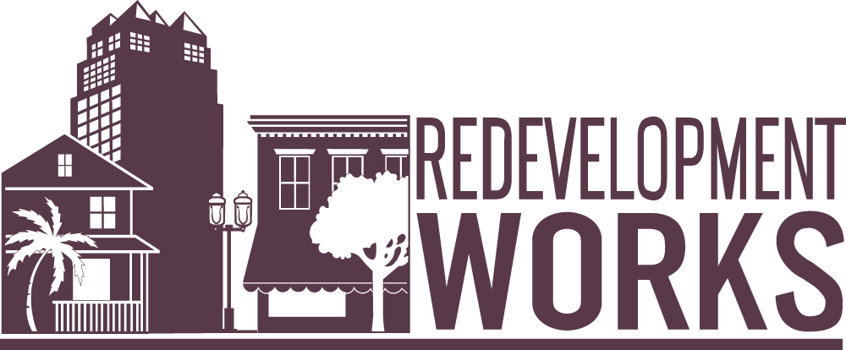

*REDEVELOPMENT WORKS SAMPLE EMAIL TO FLORIDA SENATORS*

With legislation under consideration during Florida’s 2018 session ([HB 17](https://www.myfloridahouse.gov/Sections/Bills/billsdetail.aspx?BillId=59889&SessionId=86) and [SB 432](https://www.flsenate.gov/Session/Bill/2018/00432/?Tab=RelatedBills)) that would have a significant negative impact on the survival of community redevelopment agencies (CRAs) if passed, the [Redevelopment Works](http://redevelopment.net/redevelopment-works/) campaign is spreading awareness about the importance and value of redevelopment in Florida.

CRAs are incredibly successful tools for breathing new life into communities that have been neglected or forgotten. Their purpose is to eradicate physical blight in its many forms – through local leadership and a publicly vetted redevelopment plan. There are no state or federal monies spent by CRAs. Rather, improvements are funded through tax increment funding, which comes from future property value increases in the area.

For a look at how CRAs are improving communities across the state, we encourage you to review the following materials:

* [Redevelopment Works Testimonial Videos](http://redevelopment.net/redevelopment-works/#1516748726307-f3fa3996-cbf3)
* [Redevelopment Works News Clips](http://redevelopment.net/wp-content/uploads/2018/02/02.20.18_Making-Headlines-Graphic.pdf)
* [Florida Redevelopment Awards 2017 Best Book](http://redevelopment.net/wp-content/uploads/2017/10/FRA-2017-Best-Book.pdf)

Additional information on CRAs can be found on the Florida Redevelopment Association’s website at <http://redevelopment.net/redevelopment-works/>.

Sincerely,

[SIGNATURE]