|  |  |  |  |
| --- | --- | --- | --- |
|  | 10/31/2016 |  | |
| |  |  | | --- | --- | |  |  | |  |  | |  |  | |  |  | | |  | |
| Community Conversations Report  *Competitive Florida Partnership: City of Stuart 2016-2017* | | | |
|  |  | | |  |  |  | | --- | --- | --- | |  |  |  | |  |  |  | |  |  |  | |  |  |  | |  |  |  | |  |  |  | |
|  |  | | City of Stuart Deliverable 3 |

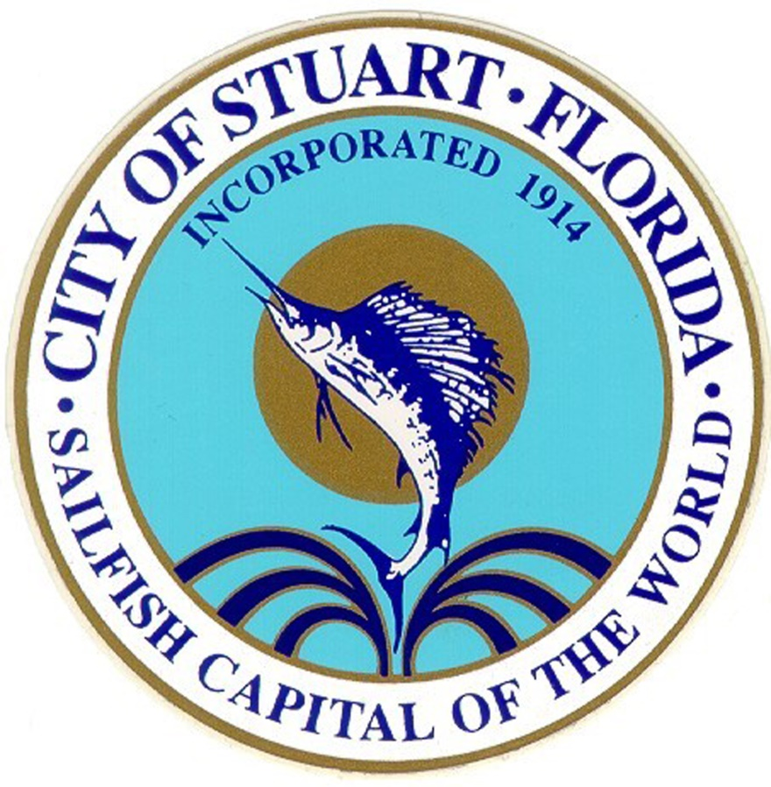

Community Conversations Report

Competitive Florida Partnership: City of Stuart 2016-2017

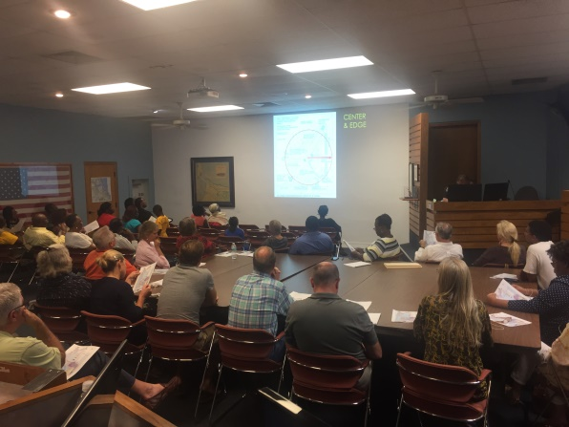

Redevelopment Workshop

The City of Stuart has been designated a 2016-2017 Competitive Florida Partnership community. In order to maintain a thriving and vibrant city, the City of Stuart identified the need to develop an economic development strategy. As part of the Competitive Florida Partnership planning process, this Community Conversations Report is the third deliverable as part of the City’s contract with the Department of Economic Opportunity. The purpose of this report is to describe the two forms of community outreach that has been accomplished by the City of Stuart and report on the information gathered from the outreach activities.

# Outreach to Date

City of Stuart has started implementing the Stakeholder Engagement Strategy. There have been three areas of priority in which various different types of community conversations have occurred.

### REDEVELOPMENT

The City of Stuart Community Redevelopment Agency held two public workshops that addressed redevelopment. The first public workshop on February 9th was attended by approximately 45 City residents. The workshop began with a presentation regarding redevelopment concepts and background. Live polling was utilized to help identify topics that wanted to address as part of the CRA’s redevelopment efforts.

Our second workshop was held on February 27th and incorporated the results of the February 9th public workshop. This meeting was attended by members of the public, Commission, Community Redevelopment Agency and Community Redevelopment Board members; however, a sign in sheet is not available.

Both workshops identified important redevelopment issues. The public seemed to favor redevelopment of a mix use type along some major corridors; such as US1, Palm Beach Road and East Ocean. Some strategies identified by attendees were to adopt a complete streets strategy, address the US1 Corridor, explore a variety of housing options and focus on street level neighborhood improvements. The redevelopment of the US 1 corridor was identified as a priority project for the stakeholders.

Analysis is as follows:

Urgency- US 1 Corridor Redevelopment

Newness- Adopting a complete streets policy was widely accepted by public.

Equity- A variety of housing options was supported by stakeholders and considered to be necessary to have a thriving city.

Important- US 1 Corridor redevelopment, including streetscape enhancements that are consistent with complete streets policy, will have a significant impact on the economic, livability and sustainability of the City of Stuart.

Sustainability- Redevelopment of US 1 will allow for a sustainable future for the City of Stuart. The US 1 corridor consists of many older shopping plazas that are out of date and underutilized. The appropriate redevelopment of this corridor will result in a financially sustainable US1 corridor and he reuse of many of these properties will result in an environmentally sustainable City.

### DATA

In terms of implementing the strategy for the data priority, the following Community Stakeholders were contacted per the strategy, and with the following result(s):

* Economic Council of Martin County – Does NOT collect any data
* Chamber of Commerce – No final response, assumption is that limited data is collected
* Small Business Development Center/IRSC – A PowerPoint presentation was received by the City of Stuart, “ SBDC@IRSC – Impact 2015” identified local businesses that went through the Entrepreneurial training offered by the SBDC.
* City of Stuart – Collected the Business License applications and the types of questions asked of new businesses. Plan on analyzing the application to identify opportunities for improvement so the City can collect the most data at this opportunity.
* Business Development Board – Non responsive.
* MCBOCC Tourism- Received County data regarding the following: FL Taxable Spending, Rental data, and Stuart Lifestyle Reports. Conversation has developed on costs associated with providing detailed City of Stuart data.
* TC Regional Planning Council – No formal responsive, however Tom Lanahan, Assistant Director of TCRPC did attend the Community Asset Exercise as an “expert” and has been open to have further conversations on the topic.

The following were the questions posed to the stakeholders:

1. What type of data do you collect?
2. Do you collect data specific to the City of Stuart?
3. Would you be willing to share this data with the City of Stuart?

Analysis is as follows:

Urgency- Data collection is necessary and urgent in order to assist the City of Stuart in implementing a successful economic development strategy.

Newness- None found.

Equity- Since the typical community stakeholders do not collect data, there is certainly a need for ALL stakeholders to participate in a more in-depth data analysis of the economic climate in the City of Stuart.

Importance- As a result of the slow process of data collection it could affect policy and future City projects.

### HOUSING

The City of Stuart has begun reaching out to the Housing stakeholders identified in the Stakeholder Strategy Report. To date, the City has conducted one-on-one interviews with each of the five city commissioners, including the Mayor regarding their thoughts on housing policy and the relationship between housing and economic development. Questions posed during the interviews were as follows:

1. What do you think are the primary benefits of living within Stuart? Do you see any potential drawbacks to living in Stuart?
2. Ideally, what kinds of residents do you want to attract to Stuart?
3. How do you see population growth as fitting into our economic development plan?
4. With an increasing population, how do you think Stuart should adapt to increased density and what are the main challenges you foresee with this?
5. How should the city of Stuart encourage the development of more multifamily housing?
6. How can the city work with the Martin County Public School System to improve and better market Stuart’s schools to young families?
7. What sorts of housing policy initiatives would you like to see the City implement?
8. Would you been interested in expanding existing CRA programs to improve housing, such as the Paint-Up program or the façade improvement program?
9. How should affordable housing be addressed? Would you support policies designed to increase the availability of affordable housing in Stuart?
10. How do you see housing fitting into the overall economic development plan?
11. What sort of housing data and data analysis would help you in making decisions about housing policy?

A key take-away from the commissioner interviews is the realization that most of the commissioners are not well-informed about either the housing market or housing policy. This lack of knowledge, coupled with a lack of data, creates a barrier to implementing housing policies. In addition, the commissioners seem divided on what role the government should play in the housing market, as well as on key issues such as increasing density and providing incentives for affordable or attainable housing.

The City of Stuart held an in-house roundtable discussion on March 10 with planners from its Development Department in which they discussed housing perceptions, opportunities for increasing housing, and data needs. Some of the key issues raised include the lack of available land, the current residents’ aversion to density increases, and the slow pace of residential redevelopment.

On April 4, the City met with representatives of Leaders United, a group of young civic minded professionals, to hear their thoughts on economic development and housing. The focus group asked the participants to discuss what they do and don’t like about their current housing, as well as their perceptions about Stuart. Interestingly, while there was general consensus about the housing in Stuart being hard to find and expensive, many of the key takeaways did not relate to housing per se. Some of the main complaints about Stuart as a community included the lack of career opportunities and low pay, the poor dating scene, the lack of diversity, and the lack of nightlife. However, despite these drawbacks, several of the participants wanted to live closer to Downtown Stuart, citing the beautiful waterfront, the friendly community, the quaint small town feel, and walkability.

Due to time constraints, the City of Stuart has not been able to hold additional focus groups; however, staff is continuing to pursue additional stakeholder outreach for this priority. The City is currently working to create surveys for both realtors and key industry employees in order to learn more about the local housing market. Additional focus groups may be organized as well. Overall, City staff is strongly committed to continuing to engage key stakeholders throughout the process.

Analysis is as follows:

Urgency – The City staff and commissioners currently lack the knowledge and data to formulate a strategic housing policy.

Newness – One of the planners mentioned she’d recently been contacted by a developer interested in affordable housing. This developer has been identified as a stakeholder we’d like to reach out to in the future.

Equity – While most stakeholders support increasing the availability and variety of housing options, there is not much support for “affordable housing”.

Important – Increasing our knowledge of the local housing market and successful housing policies is crucial for this priority. We hope that additional stakeholder outreach through the employee and realtor surveys will help to fill this gap.

Sustainability – Without additional diverse housing opportunities, the population of the city of Stuart will continue to stagnate. Increasing housing options is crucial to the city’s long-term community well-being and sustainable economic growth.

# SUMMARY

Through the City of Stuart Stakeholder Engagement Strategy implementation, staff has determined that the overall scope of the engagement strategy must be reconsidered. Through our initial community conversations it has brought to light that data is a critical and time consuming component that needs to be addressed in order for the City to be able to produce viable economic results.

The housing priority has proven to be a significant and monumental matter that requires large sums of dedicated staff time. City staff has only scratched the surface with holding initial conversations with City of Stuart Commissioners and Planning staff. This process has generated a healthy discussion amongst City staff that impacts the rest of the stakeholder strategy implementation. It is the City’s opinion that our priorities should be shifted to only assess Housing and Data further. The Business Retention priority is now to be considered a low priority, and unlikely to be implemented due to limited resources and time.

In summary, the community conversations have confirmed the initial areas of priorities that were integrated in the Stakeholder Engagement Strategy. The community conversations have caused staff to reconsider the implementation of said strategy in order to achieve the most information and data from the Competitive Florida Partnership program.

# Supporting Documentation

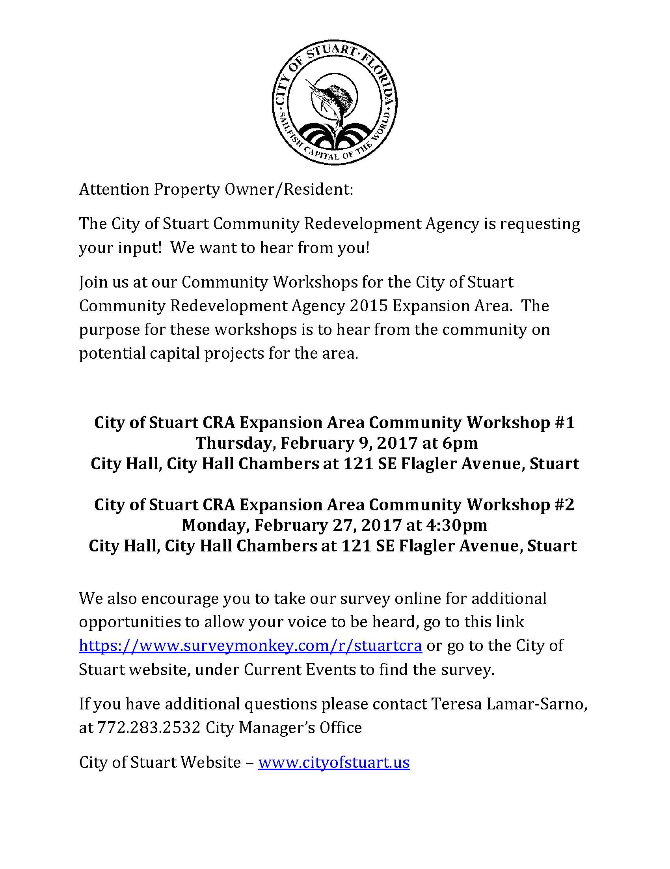

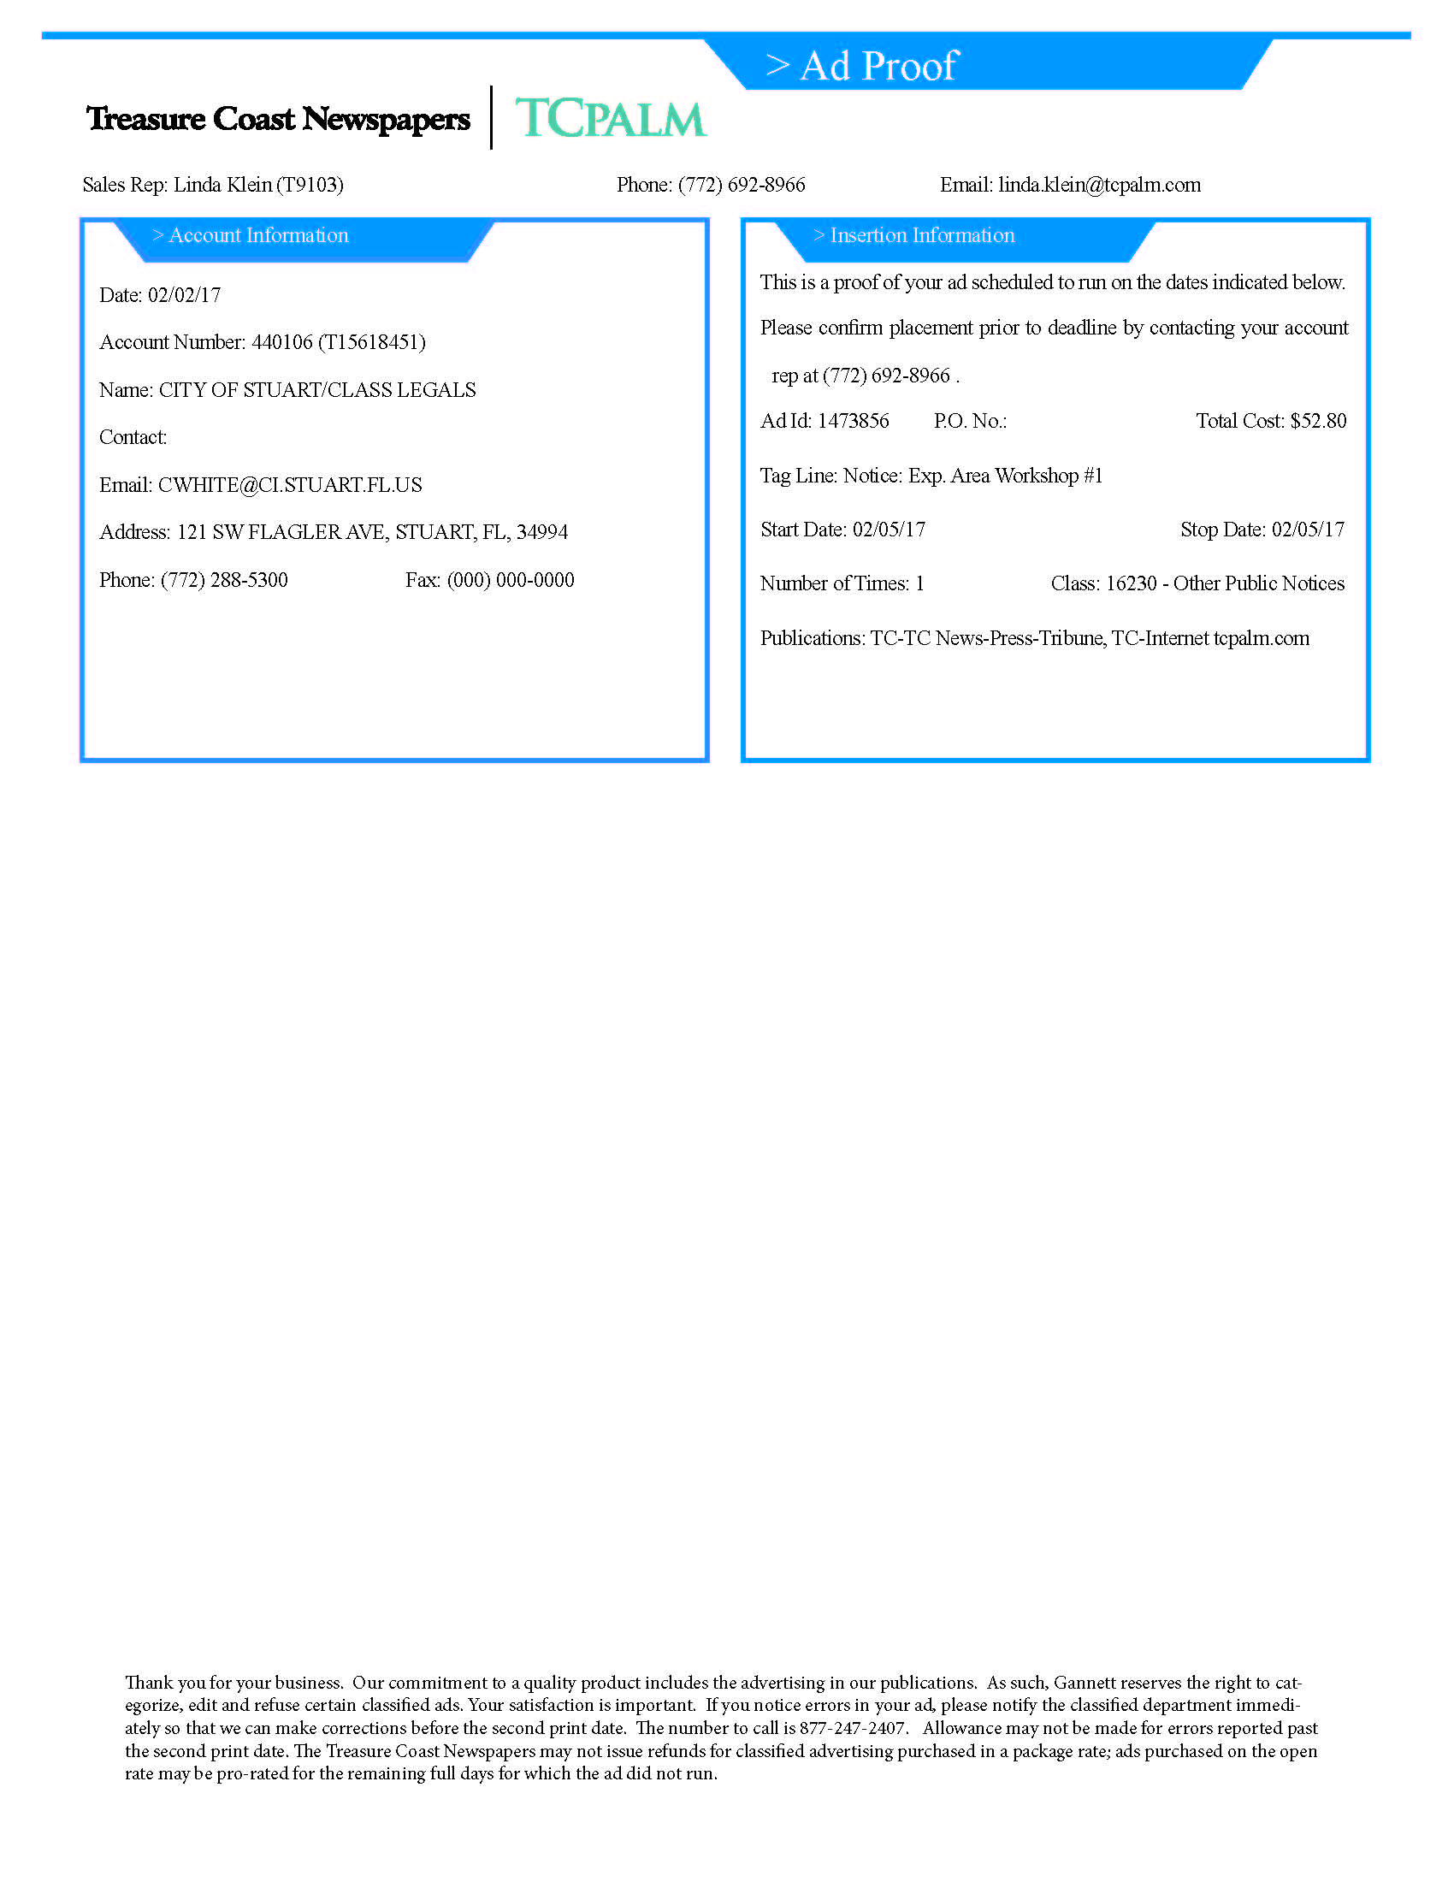

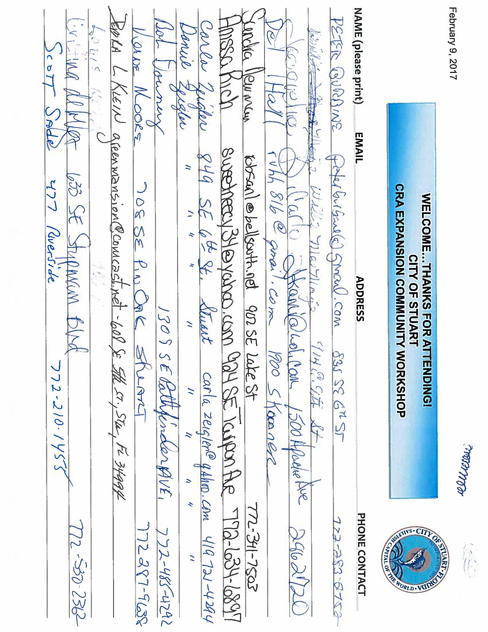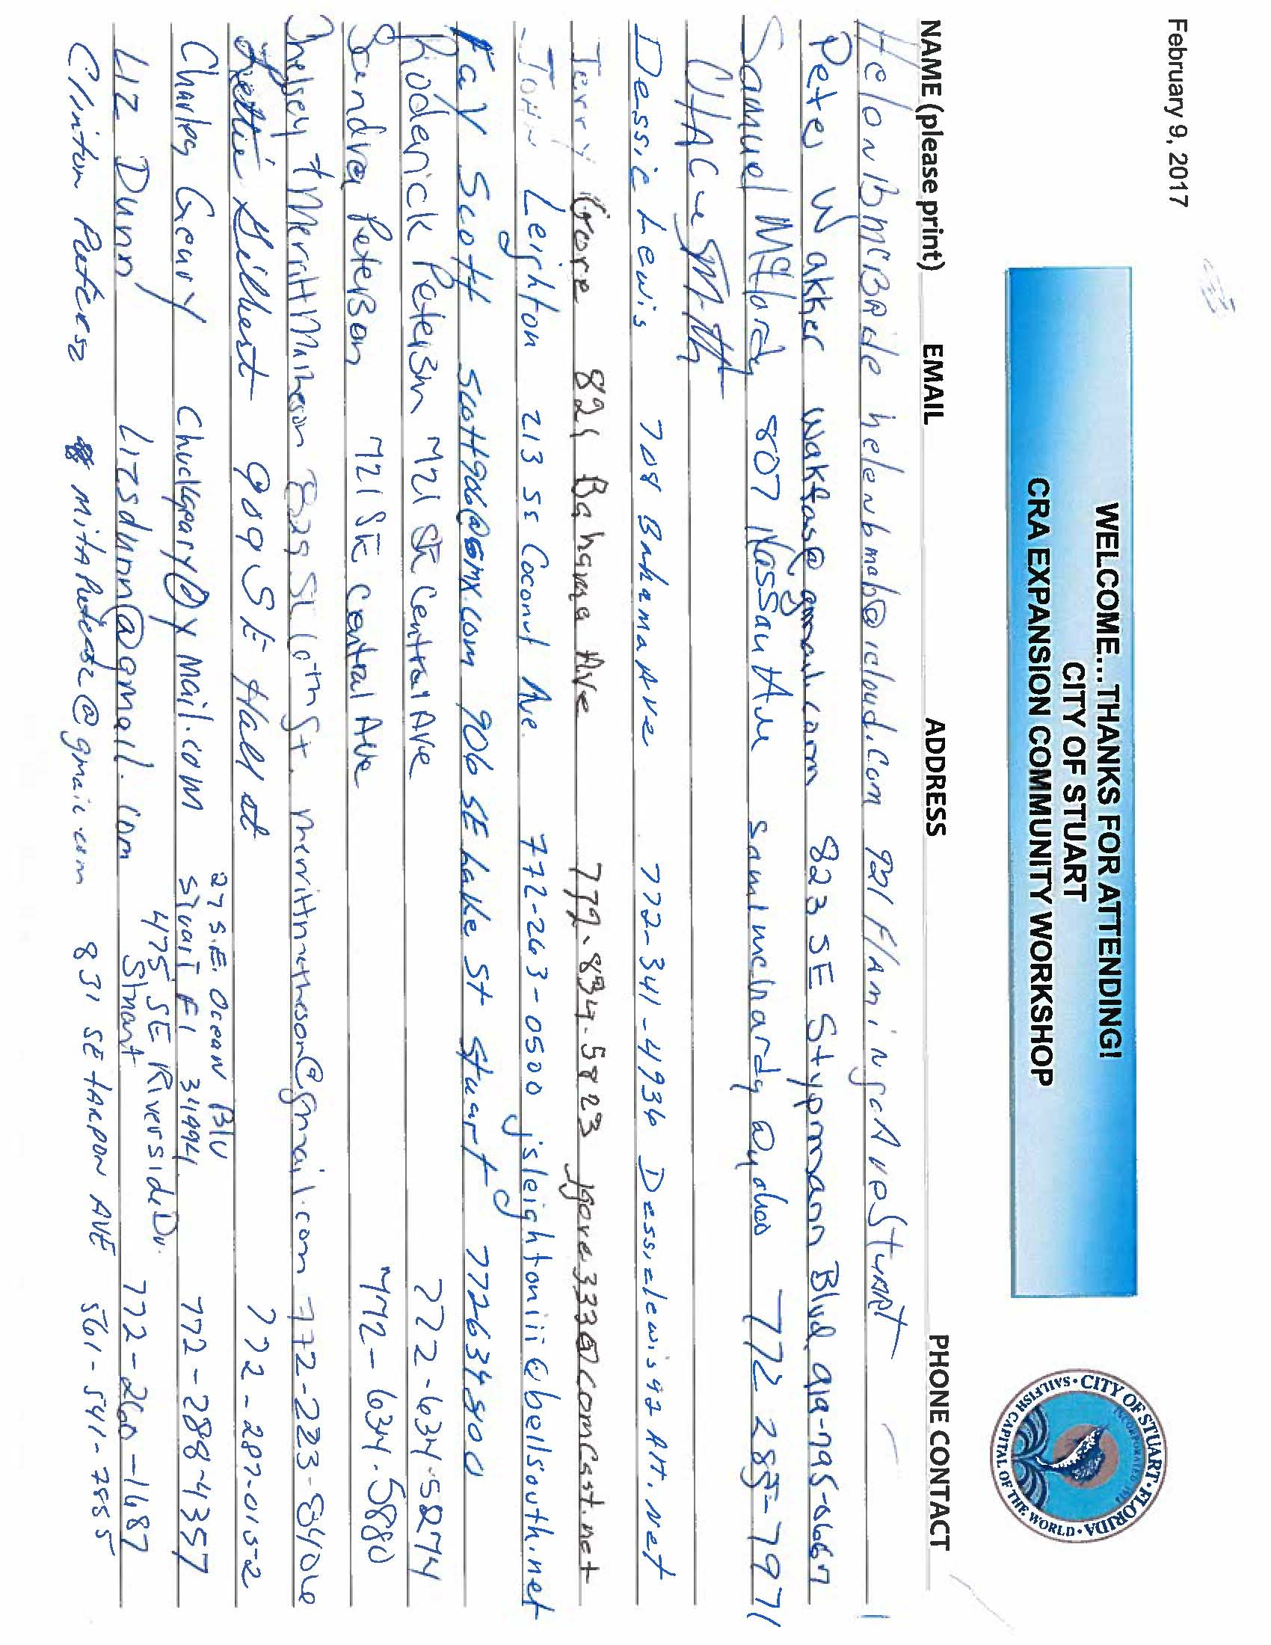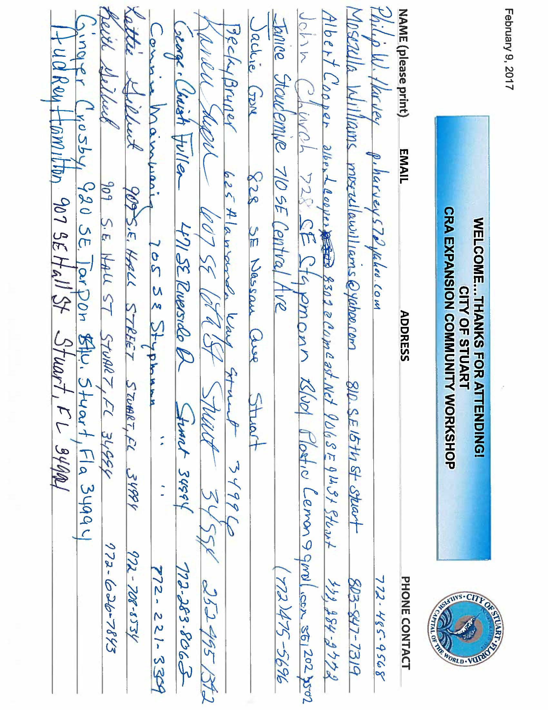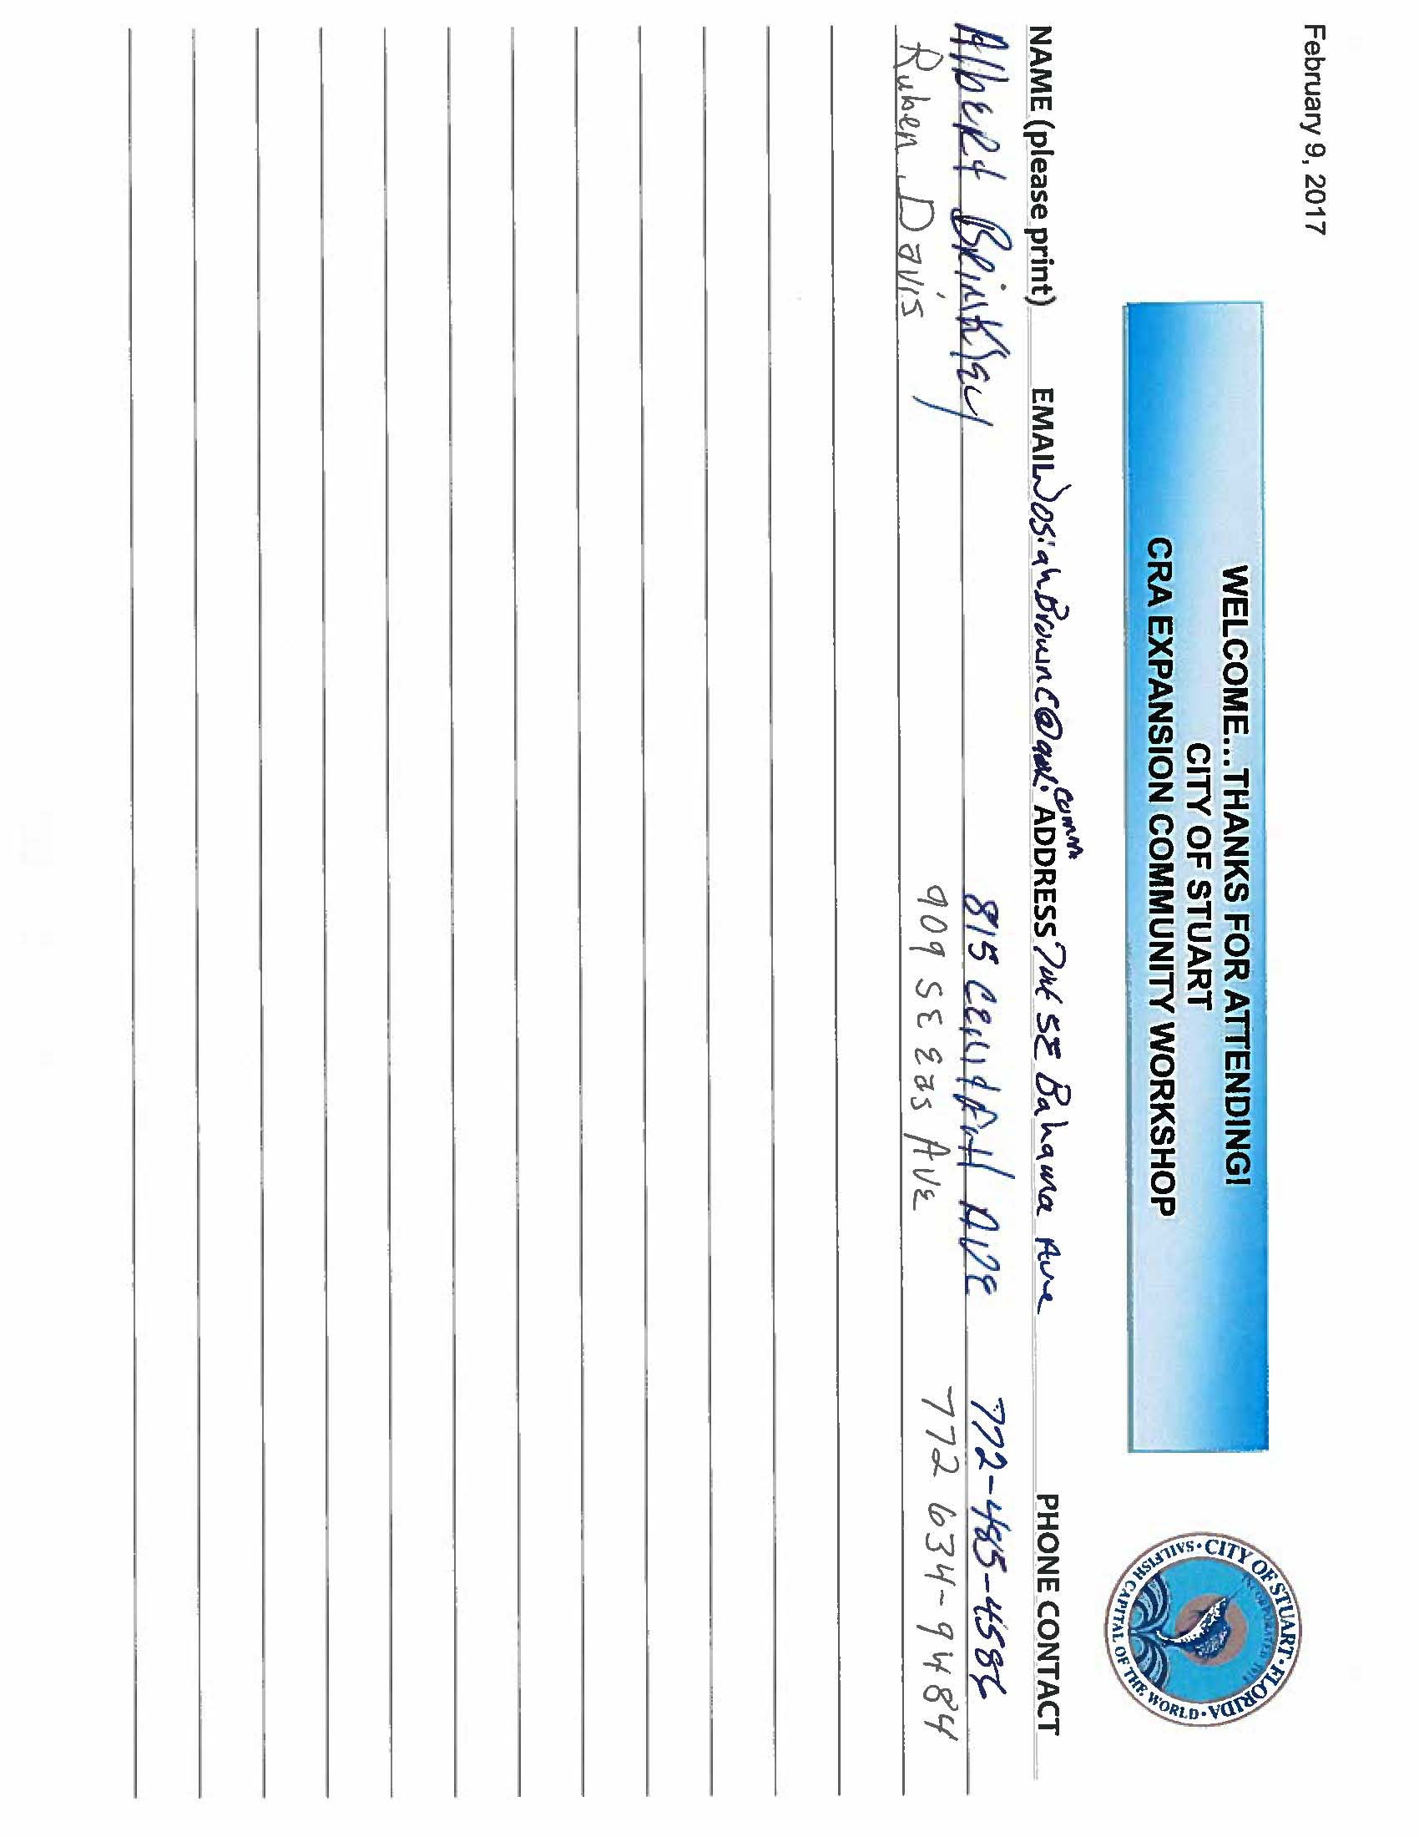

***City of Stuart Community Redevelopment Agency Community Workshop #1***

***Meeting Agenda***

February 9, 2017

6pm

Type of Meeting: Community workshop meeting with presentation, live polling and gathering input from the public on the Community Redevelopment Area expansion.

Meeting Facilitator: Teresa Lamar-Sarno and Marcela Camblor

Invitees: Public

1. Call to order
2. Introductions of staff and dignitaries
3. New business
4. CRA Objective with Community Workshop
5. Presentation and live polling by Marcela Camblor, Principle, Marcela Camblor and Associates, Inc.
6. Q & A

# Adjournment

Economic Development Focus Group: Leaders United

April 4, 2017, 8:00 AM

* **Attendees**
  + Staff
    - Teresa Lamar-Sarno
    - Nicole King
    - Annelies van Vonno
    - Mayor Tom Campenni
  + Leaders United
    - Debi McKay
    - Ronnie Kirchman
    - Amy Bottegale
    - Kimberly Perrin
    - Elisabeth Glynn
    - Lindsey Concanna
    - Natalie Dismangles
    - Steven Shultz
* **KEY TAKEAWAYS**
  + Most attendees do not live in Stuart, though several of them would like to
  + Things People Like About Stuart
    - Location on the river and the waterfront
    - Friendly community
    - Quaint, charming old Florida, small town feel
    - Everything is close together – walkable, has the tram
  + Things People Don’t Like About Stuart
    - Housing is too expensive and there’s not much available, what is available needs renovations
    - Lack of career opportunities and low pay
    - Bad dating scene
    - Shops and restaurants close too early, no nightlife
    - Lack of diversity
    - Too many old people
    - Not enough parking
* **Housing Discussion**
  + Where do you currently live? How close is your home to work? Were commute time and public transportation options factors in where you chose to live?
    - Debi
      * Lives in Port St Lucie
      * 9 miles commute
      * Bought house as second home before moving to the area. Moved down here after finding local job
      * Has been trying to move to Martin for 2 years, but the type of house she wants doesn’t exist in Martin County
      * Looking for 2b/2b townhouse in younger community - doesn’t want to be the youngest in the neighborhood
    - Ronnie
      * Lives in Palm City
      * 5 miles commute to work
    - Amy
      * Lives in Port St Lucie
      * 10 mile commute
    - Kimberly
      * Lives in Jensen Beach
      * 3.5 mile commute
    - Elisabeth
      * Lives in Palm City
      * 1.5 mile commute
    - Lindsey
      * Lives in Stuart
      * Has two offices – commute is 1 mile for Stuart office and 9 miles for PSL office
      * Location and nearness of work was important to housing choice
    - Natalie
      * Lives in Tradition in Port St Lucie
      * 45 minute commute to work in Stuart, approximately 15 miles
    - Steven
      * Lives in Stuart
      * 5 mile commute
    - All – For the most part, commute time was not factor in housing choice. Primary factors were housing cost, school system, and community factors
  + Why did you choose to live there?
    - Debi – Bought house in PSL for great price 7 years ago, has been looking for homes in Martin County
    - Ronnie – Grew up in Martin County and wanted to live here. Initially, he couldn’t afford to buy a house in Martin County, so he lived in PSL before building his own home in Martin County. Strong factor was the desire to send his kids to Martin County schools.
    - Amy – Single mother who raised her daughter in Jensen for schools system. Bought cute house in PSL near US1 and Sam’s Club. House is affordable and very accessible to Martin County. Loves Martin County and wants to be close by but says there’s nowhere in Martin County where she could pay under $1000 a month. As a single woman, one of her complaints is that there are no young available men in this town.
    - Kimberly – Grew up in Orlando and has lived in PSL and in the Keys. Loves the Stuart area and the water and boating lifestyle. Lives in the Falls neighborhood near the mall because she wanted a new house.
    - Elisabeth – Grew up in Baltimore and initially moved to Pompano for husband’s job. Husband’s sister and parents lived in Palm City. After visiting frequently for family holidays over the course of 5-6 years, family moved to Martin in 2014. Loves the nice, kind, warm people, and has noticed a major difference in friendliness level of Palm City compared to Ft Lauderdale. Loves the school system and the quirky, fun community in Old Palm City. She notes that their house value has doubled since they’ve moved here.
    - Lindsey – Had worked in Martin County for 10 years. Used to live in PSL/Ft Pierce, but boyfriend lived in West Palm. When they moved in together, they initially looked in West Palm, but decided to get a place in Stuart because the price was a little cheaper and they could be close to Downtown Stuart. No kids yet, young couple that wants to have fun!
    - Natalie – Lives in Tradition. Had been living in Ft Lauderdale and thinking of buying a condo, but realized she could buy a house with yard in PSL for the same price. Loves living in Tradition and has a lot of friends in the community. The neighborhood has lots of diverse people around her age – she says it’s a melting pot. There are lots of things to do and businesses stay open later than in Martin County. The school system is bad and she considered buying or renting house in Martin County for access to the school system, but it was cheaper to just pay tuition for private school
    - Debi – Encourages us to look up P St City near Atlanta for good ideas
    - Steven – Grew up in Ft Pierce and used to live on island near Jensen Beach. After he married and had kids, he moved to Martin County for the school system. He likes everything about Martin County, and while he could have found something cheaper in PSL, he chose to spend more to live in Martin.
  + What do you like about where you live?
    - Debi – House is already paid off. Does not like the community or area
    - Ronnie – House is not in a gated community. They have a nice yard and pool. They are close to i95 and turnpike. It’s easy to get to work, and they have lots of friends nearby.
    - Amy – She likes the friendly neighborhood and community. She likes her house, but wishes it was in Martin. She’s on a nice quiet street and close to everything.
    - Kimberly – Likes the neighborhood, but would prefer to live in Sewell’s Point. She wants to be closer to Downtown Stuart.
    - Elisabeth – She likes Old Palm City because it’s not a cookie cutter neighborhood and she can get to either bridge easily. It’s easy for her to get to downtown quickly and also easy for her husband to get to I-95 for his commute to work in Pompano. They are close to Palm City Elementary. She wishes there was well paying work for husband in Martin county, since her husband’s commute makes taking care of kids harder.
    - Debi – Debi thinks that the lack of career opportunities is a huge issue. She moved to the area for the small-town charm, knowing that doing so would mean a loss of salary and career opportunities.
    - Lindsey – She loves where she lives and thinks it’s perfect for this part of her life. She wasn’t ready to buy yet and wanted to be in Martin. She likes being close to 95, downtown, and the water. She has friends in the neighborhood. She also says that most houses in area too pricy for her and complains that there are no opportunities to move up career-wise.
    - Natalie – Likes her fun neighborhood. She is close to 95, St Lucie West, and Ft Pierce. She loves working in Stuart but does not come down here to socialize very often since things close so early.
    - Steven – He loves his location in Bay Colony near Britt Road and North River Shores. His commute is easy and the school system in good. He loves being near Total Wine.
  + What don’t you like about where you live?
    - Debi – Her neighborhood has 2 houses in foreclosure which are eyesores. St Lucie does not regulate homes and rentals – no code enforcement.
    - Ronnie – He doesn’t like next door neighbor very much. He would also like a larger property with more privacy.
    - Amy – She wants to be close to walkable downtown
    - Kimberly – The ingress/egress of neighborhood is the mall entrance which makes for terrible traffic.
    - Elisabeth – She wants more property and privacy. She says the neighbors can be a little intrusive. She would prefer to be on sewer rather than septic.
    - Lindsey – She now wants to own, and would like to have additional parking spaces
    - Natalie – She doesn’t like that she has to ask the HOA for permission to fix up or change anything on her home
    - Steven – He doesn’t like being on well water. He would like to have a waterfront house.
* Stuart
  + What do you like about Stuart?
    - Debi – She likes the river and the waterfront. She thinks Stuart has the nicest people in the world.
    - Ronnie – Loves the water and boardwalks. Would love to see boardwalks extended
    - Amy – She thinks Stuart is beautiful and she likes the community feel. She thinks downtown Stuart is super cute and would love to live there.
    - Kimberly – Loves the quaintness of downtown and the old Florida feel
    - Elisabeth – Stuart is quaint, charming, and full of unique mom and pop stores
    - Lindsey – Stuart is quaint, charming, and full of unique mom and pop stores. She loves that it’s easy to get around, but thinks we need more parking. She loves the tram and uses it frequently.
    - Natalie – She likes working here, but has no intention of moving here.
    - Steven – Loves the water and waterfront.
  + What don’t you like about Stuart?
    - Debi – perception that its for old people
    - Ronnie – shuts down too early, no affordable housing
    - Amy – wants more young people, more single men, better jobs, better pay
    - Kimberly – train is terrible, inconvenient, and noisy
    - Lindsey- hard to start a family because it’s too expensive, no good men, not enough parking
    - Natalie – no diversity, no African American community, large separation between poor black people and the rest of community
    - Steven – no nightlife
    - Elisabeth – not a lot she doesn’t like, parking can be an issue
  + Are you willing to fix up a home?
    - Kimberly – Would be willing if the house was on the water. Speaking as an interior designer, she says that most houses in Stuart need major remodeling
    - Lindsey – would be willing, but it would depend on location and price
    - Debi – She says it’s not about money, but rather about finding the right home in the right community. Complains that most of the communities she likes in Stuart have an elderly population.

SURVEY RESULTS

