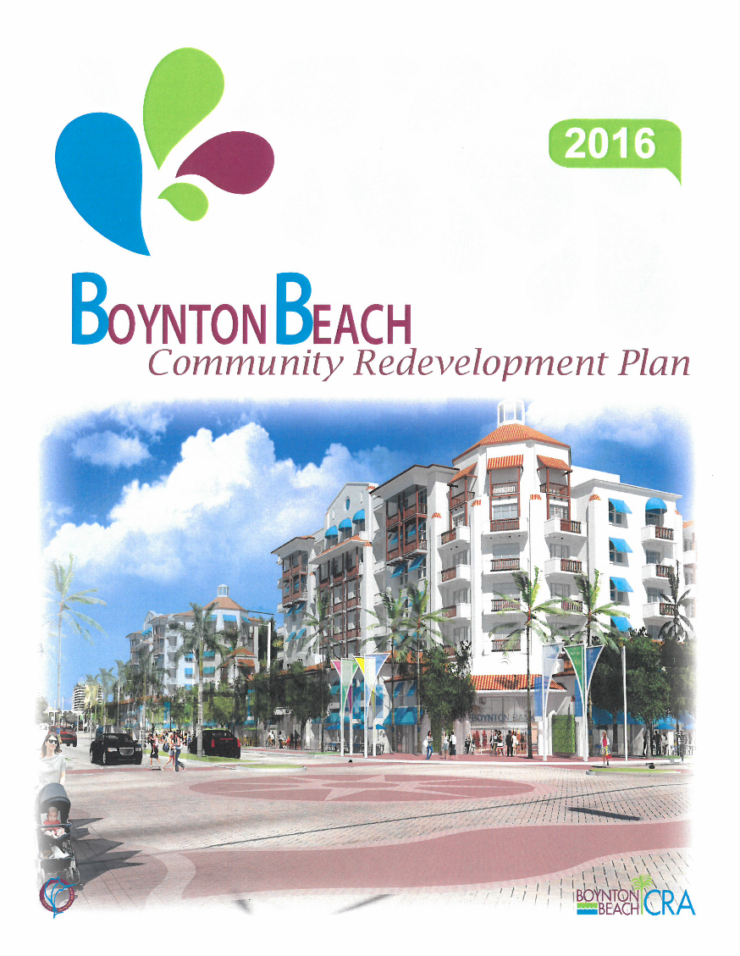

**Boynton Beach Community Redevelopment Agency**

**2017 Roy F. Kenzie Awards**

**Planning Studies 100 Word Description**

The goal of the 2016 Boynton Beach Redevelopment Consolidation Plan was to amend, restate and consolidate all CRA plans into a single document. While separate “districts” have been identified and may warrant individual attention because of their specific character and unique issues, CRA staff along with City staff created a consistent, comprehensive urban design framework for redevelopment strategies in the Boynton Beach CRA district. The consolidated plan provides a clear overall vision for the entire area, easy to understand by the redevelopment professional seeking opportunities as well as the public at large.

Contact: Tracy Smith-Coffey

561-600-9096

Smith-CoffeyT@bbfl.us