Murdock Village a go
By GARY ROBERTS Staff Writer
MURDOCK — After listening to two hours of public testimony, some for and some against, the County Commission Tuesday approved the sale of almost half of Murdock Village, which has been a lightning rod of taxpayer discontent for a dozen years and a costly regret shared by all.
Private Equity Group, LLC of Fort Myers will pay $11.6 million in cash for 452 acres of vacant, county-owned land, located between U.S. 41 and State Road 776. The developer envisions up to 2,400 single-family and multifamily units, 200,000 square feet of commercial and retail space, and a 150-key hotel.
In addition, the developer agreed to construct “public infrastructure” on 75 acres along a central corridor, from U.S. 41 and State Road 776, that would include an expanded O’Donnell Boulevard, sewer and water, sidewalks, 10-foot-wide multimodal pathways, street lighting and landscaping. PEG would then deed the property back to the county, which would reimburse the developer up to the $11.6 million purchase price.
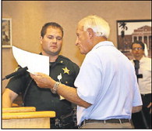
Bill Bigelow had to be escorted from the podium after twice being told his time was up.
The County Commission voted 4-1 to accept the proposal and sale price, with Commissioner Chris Constance dissenting. Specifically, Constance would have preferred more commercial development to create jobs. In addition, he cited the absence of a developer’s agreement that spells out a firm timeline for construction.
“I have a lot of questions,” he said. “I want performance guarantees and I know it’s not what we’re getting here.”
But other commissioners see the sale as a means to an end that will bring the property back on the tax rolls, generating huge revenue if and when the development is fully realized.
Commissioners also spent two hours making their case, explaining why the county is willing to take less money upfront in exchange for long-term payback.
The tax benefits include an immediate $15 million in taxable land value of the property. Then a litany of projected revenues would follow, such as $2.5 million in annual ad valorem tax after the project is built out and, over 20 years, more than $900 million in taxable sales and total net benefit of $151 million to all taxing districts, according to economic impact studies.
“Murdock Village has been, and remains, a tremendous economic opportunity,” said Lucienne Pears, county economic development director. “This is a market-driven approach.”
According to the contract, the developer would pay impact fees on all development except for credits given toward public pathways. And if all the development in the final site plan does not occur within 10 years, PEG will forfeit its right to any unused residential or commercial entitlement.
Commissioner Ken Doherty admitted the sale price wasn’t all it might have been, but said the public infrastructure and eventual development would offset any immediate shortfall. He stressed that today’s real estate market does not allow the county to recoup its $128 million cost of acquisition.
“The market decides the rules. We took a shellacking,” he said. “This is about as good as we’re ever going to get.”
Chairman Bill Truex also said this would be an opportunity lost if the Murdock Village property was not sold.
“If we don’t do this now, we’re going to have this 20 years from now,” he said.
A number of local business groups, representing chambers of commerce and the building and real estate industries, also gave their endorsement during the public hearing.
“Private Equity Group has a proven and solid track record in land development ... and this will have a positive ripple effect on the rest of Murdock Village,” said Alyson Burch, Charlotte County Chamber of Commerce president. But some in the audience could not get past giving away the land in exchange for a potential payout.
“Let me remind you we are in this fiasco because of speculation,” resident Ed Zubal said. “I and many others see this as a gross misrepresentation of your responsibility.”
At the end of the public hearing, PEG President Don Schrotenboer stepped to the podium in response to the criticism from the public and in defense of the final contract.
“The purchase and sales agreement has merit and speaks for itself,” he said. “If this is such a sweet deal, and it might be ... why didn’t any other developer come forward in the last 30 days when it was advertised? It proves this is the best plan for Murdock Village.”
Schrotenboer concluded by invoking the words of President Abraham Lincoln.
“And I quote: ‘The only way to predict the future is to create it.’ You have an opportunity in Murdock Village for Charlotte County to create that legacy.”
Email: groberts@sun-herald.com
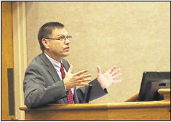
Charlotte County Budget Director Gordon Berger tries to clear up some of the more technical points for both the County Commission and the audience.
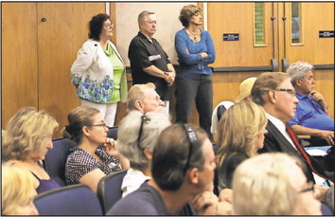
The crowd waits for the decision on Murdock Village.
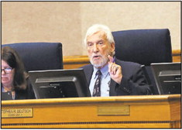
Commissioner Stephen R. Deutsch.
SUN PHOTOS BY BETSY WILLIAMS
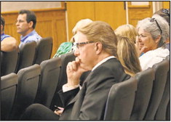
Don Schrotenboer, president of Private Equity Group, the developer of the proposed Murdock Village project.
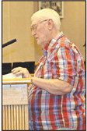
Don Wellin expressed his concerns about Murdock Village.
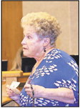
Susan Domato was the first from the audience to take the podium to express her views.
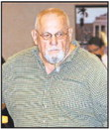
John Surkan leaves the podium after expressing his disgust with the whole deal.

