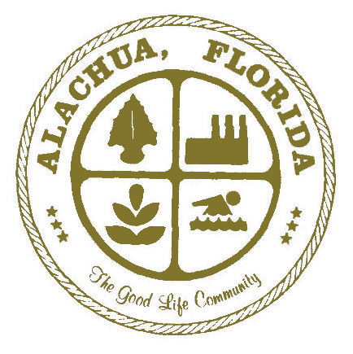
CITY OF ALACHUA
JOB DESCRIPTION

COMMUNITY REDEVELOPMENT AGENCY (CRA) COORDINATOR

DEPARTMENT: Planning and Community Development

REPORTS TO: Planning and Community Development Director

SUPERVISES: None

FLSA: Nonexempt

GENERAL DESCRIPTION:
Professional level work implementing initiatives of the CRA within the City. Work includes planning, marketing, graphic design and community outreach for the purpose of retaining and attracting businesses and creating a desirable destination for residents and visitors. Work is performed under the general direction of the Planning and Community Development Director.

ESSENTIAL JOB FUNCTIONS:
- Collect and analyze demographic, land use and economic data for purpose of conducting redevelopment activities.
- Prepares and implements long-range and short-range economic development and redevelopment plans, grant programs and applications in accordance with state law and local policy;
- Assists existing businesses in preparing marketing and revitalization plans and implements business retention strategies.
- Develops and maintains a data system to track the progress of attracting new businesses to the CRA district.
- Recommends policies, plans, standard operating procedures, requirements and instructions to the Director that result in achievement of a successful economic development and redevelopment program.
- Encourages a cooperative relationship with downtown, neighborhood and community organizations.
- Establish a business recruitment program to encourage businesses to locate within the redevelopment district.
- Create marketing, public relations and communication campaigns to promote businesses and events in the redevelopment area.
- Prepare and submit reports regarding issues, projects, and activities related to economic development and redevelopment, including reports to be filed on behalf of the CRA.
- Establishes and maintains a list of businesses, building vacancies and properties for sale within the CRA district.
- Maintains City website as applicable to the CRA.
- Works closely with community partners, business organizations, private investors and citizens to help the Community Redevelopment Area reach its full potential as a sustainable and thriving area.
- Evaluates and reports to various boards on plan execution and progress.
- Works with various city departments to implement initiatives.

(These essential job functions are not to be construed as a complete statement of all duties performed. Employees will be required to perform other job related marginal duties as required.)

MINIMUM QUALIFICATIONS:

KNOWLEDGE, ABILITIES AND SKILLS
Knowledge of CRA goals and initiatives. Thorough knowledge of principles, practices, methods and theories of planning, community economic development and redevelopment. Knowledge of design, marketing and public relations principles. Knowledge of applicable state laws, including but not limited to Chapter 163, Part III, F.S. Knowledge of City streets, landmarks and areas for redevelopment opportunity within the CRA. Ability to develop and maintain community partnerships. Ability to operate computers and office software. Ability to communicate effectively both orally and in writing. Strong project management and organizational skills to plan and independently execute projects/tasks within specific deadlines.

EDUCATION AND EXPERIENCE
The ideal candidate will have a Bachelor’s degree in Marketing, Public Relations, Business, Planning, Public Administration or related field. Minimum of two (2) years proven experience with a Redevelopment, Main Street, or Downtown Improvement District, or similar program is preferred; or an equivalent combination of training and experience which provides the required knowledge, skills and abilities. A Master’s degree from an accredited college or university may substitute for the preferred experience.
(A comparable amount of training, education or experience can be substituted for the minimum qualifications.)

LICENSES, CERTIFICATIONS OR REGISTRATIONS
Valid Florida Driver’s License.

ESSENTIAL PHYSICAL SKILLS:
Acceptable eyesight (with or without correction)
Acceptable hearing (with or without correction)

ENVIRONMENTAL CONDITIONS:
Works both inside in an office environment and outside.

(Reasonable accommodations will be made in accordance with existing ADA requirements for otherwise qualified individuals with a disability.)

The statements contained herein describe the scope of the responsibility and essential functions of this position, but should not be considered to be an all-inclusive listing of work requirements. Individuals may perform other duties as assigned including work in other areas to cover absences or relief to equalize peak work periods or otherwise balance the workload.
By signing below, I agree and understand that I must be able to perform each responsibility set forth above to continue my employment with the City.

___________________________________ _________________

Employee Name (please print) Date

___________________________________

Employee Signature

