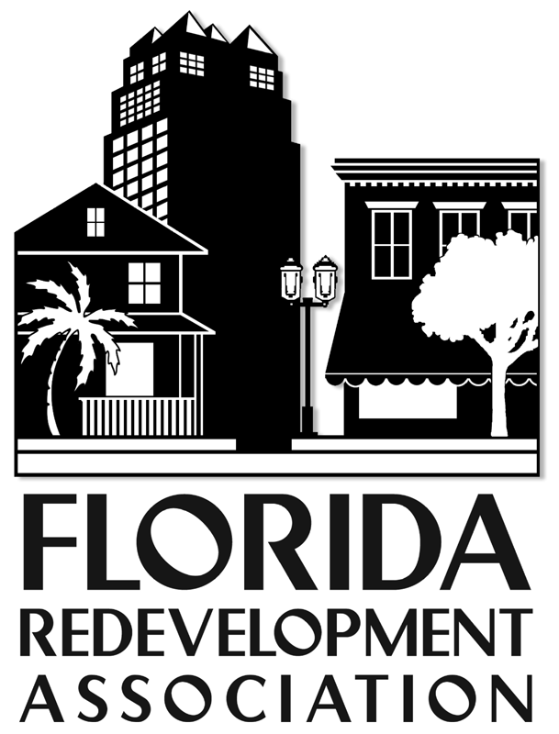 Sponsorship Form
2015 Annual Conference
October 12-14, 2016
Hilton Orlando I-DRIVE

Individual sponsorships are also available (see the list on the attached page). If you are selecting a sponsorship option that includes an exhibit booth, please also complete the “Exhibitor Agreement”. WWW.REDEVELOPMENT.NET

Company/Organization:

___________________________________________________________________________________________________
(Please PRINT OR TYPE exactly as name should appear in program and on signage.)

Contact Name ________________________________Title_____________________________________________

Address ____________________________________City __________________State ____ Zip______________
_
Phone_______________________FAX___________________EMAIL___________________________________

Authorized Signature____________________________________________________Date___________________

Program Listing - If you are not taking a booth, please summarize the products/ services you provide (10 words)

_________________________________________________________________________________________________

On-Site Representatives: IF the package chosen includes registration(s), please send the names and titles and locations of each person registered on the “Name Badge Order Form”. FRA must be notified by October 9 of name changes or additions to ensure the availability of badges.

Sponsorship Type: Package #_____ Best Book Ad ____ Tour____ Break ____Gold ____Keynote____ Event________

Amount Enclosed: $ ______________ Payment Method:

❑ Check (payable to Florida Redevelopment Association)  Visa  MasterCard

Card # ____________________________________ Exp ___/___Cardholder Phone ____________________________

Cardholder Name _______________________________________________________________________________

Cardholder Signature _____________________________________________________________________________

Billing Address: ______________________________________________________________________________________

Return completed forms to: FRA /Attention: Melanie Howe more info at: www.redevelopment.net/2015-conference

P. O. Box 1757, Tallahassee, FL 32302, (850) 222-9684, Fax (850) 222-3806 mhowe@flcities.com

For FRA Use Only: Amount Paid $____________ Check # __________ Date _______

Confirmation Mailed: __________________ Initialed: _____________

SPONSORSHIP PACKAGES
October 12-14, 2016
Hilton Orlando I-Drive
www.redevelopment.net

PACKAGE I
Capital Projects (Statewide)
1 conference registration
1 feature article in e-newsletter
5 posts on FRA social media
“Best Book” half-page listing
Exhibit booth at conference
Sponsor listing in FRA publications
FRA Membership Directory
Break sponsorship at conference
Online Business Directory Listing
Total .......................................$3,500

OTHER SPONSORSHIPS
Exclusive Keynote Sponsor… $2,500
Exclusive Session Sponsor $1,500
Tour/Break Sponsor………… $ 500
4-color Awards (BEST BOOK) Ad $1,000

PACKAGE II
List of Capital Projects (Statewide)
“Best Book” quarter-page listing
Exhibit booth at conference
FRA Membership Directory
Online Business Directory Listing
Sponsor Listing in FRA publications
Total .......................................$2,500

PACKAGE III
List of Capital Projects Statewide
Exhibit booth at conference*
FRA Membership Directory
Online Business Directory Listing
Sponsor Listing in FRA publications
Total .......................................$1,500

Based on availability. To receive an exhibit booth, exhibitor agreement must be completed along with sponsorship form. Please return completed forms to: Melanie Howe, mhowe@flcities.com, or FAX to 850-222-3806 attention FRA.

*** NOT SEEING WHAT SUITS YOUR
NEEDS? LET US DESIGN A PACKAGE FOR YOU….Contact: Carol Westmoreland
850-701-3608 or cwestmoreland@flcities.com

Name Badge Order Form
(If Registering for the Annual Conference)
October 12-14, 2016
Hilton Orlando I-Drive

Number of badges allowed: Our 4-line badges include:
Exhibitor: 2 Badges First Name/Nickname
Sponsor $1,500 to $2,500: 2 Badges Full Name
Sponsor up to $5,000 3 Badges Company Name
Company Location*
*Title may be substituted for location

(Please Print Clearly)
Company/Organization:

______________________________________________________________

1. _____________________________________
_____________________________________
_____________________________________
_____________________________________

2. _____________________________________
_____________________________________
_____________________________________
_____________________________________

3. _____________________________________
_____________________________________
_____________________________________
_____________________________________

