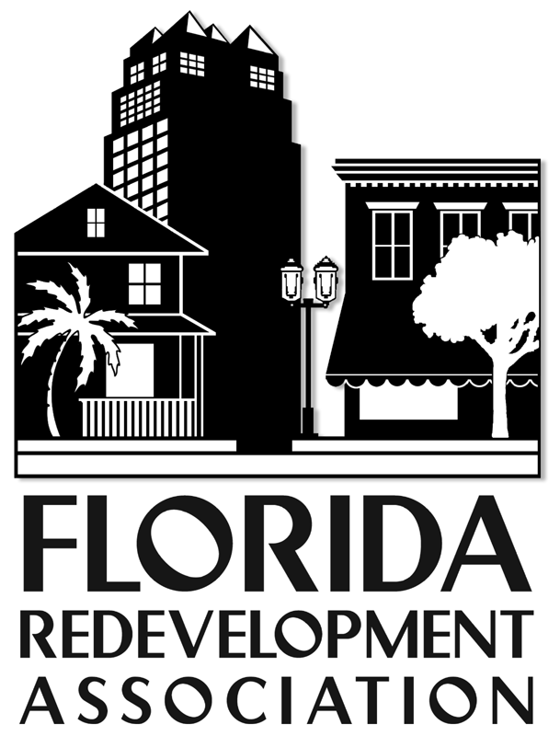

[***www.redevelopment.net***](http://www.redevelopment.net)

***Annual Conference***

**Exhibit Dates: October 11-13, 2016**

**HILTON ORLANDO I-DRIVE**

***Exhibitor Information and Forms***

***(Send in your paperwork to reserve your place in line for exhibit location (floor plan will be available after March..) and receive the 15% discount if paid by December 31, and the 10% discount if paid by March 1, 2016.)***

Please fill out the applicable forms to become an FRA 2016 annual conference

exhibitor.

**Included in this kit are:**

*Exhibitor Form

*Name Badge Form

*Exhibitor Information

*Rules and Regulations

**Contact: Melanie Howe, mhowe@flcities.com**

**ATTN: FRA EXHIBITS**

**P.O. Box 1757 • Tallahassee, FL 32302 • (850) 222-9684 • FAX (850) 222-3806**

***Exhibitor Agreement***

**2016 Annual Conference**

**Exhibit Dates: October 11-13, 2016**

**Orlando Hilton I-Drive**

# 

**Company/Organization:**______________________________________________________________________________

(Please PRINT OR TYPE **exactly** as name should appear in program and on signage.)

Contact Name _______________________________________Title____________________________________________

Address ____________________________________________City __________________State ____ Zip_____________

_

Phone_____________________FAX__________________EMAIL_____________________________________________

___________________________________________________________________________________________________

Authorized Signature Date

**Products/Services you provide (**10 words) _______________________________________________________________

**Names of possible competitors__**_______________________________________________________________________________

Booths are assigned at the sole discretion of show management and based on the date of full payment, with priority given to regular exhibitors and contributing sponsors. Please indicate your location preferences below:

First Choice ___________Second Choice _________ Third Choice __________ Fourth Choice _________

**Booth Fee* $1,200** Number of Booths Requested: __________ * Add $50 to fee if postmarked **after 8/31/16**

**On-Site Representatives:** Booth fees include name badges for up to 2 **representatives per booth.** Please complete and return the enclosed **“Name Badge Order Form”** to order all badges, **by 9/23/16.**

**Acknowledgement:** I have read and am familiar with the attached information regarding the rules and regulations for the 2016 FRA Annual Conference exhibit hall, and payment is enclosed.

________________________________________________________________________________________________

Authorized Signature Date

**Amount Enclosed: $ ____________** **Method of Payment:**

❑ Check (payable to **Florida Redevelopment Association)**  ❑ Visa ❑ MasterCard

Card #_______________________________________________Exp.___/___Cardholder Phone___________________

Cardholder’s Name (PRINTED) _________________________________________________________________________

Cardholder’s Signature _____________________________________________________________________________

Billing Address: __________________________________________________________________________________

**Return completed forms to: Florida Redevelopment Association Attention: Melanie Howe**

**P. O. Box 1757, Tallahassee, FL 32302, (850) 222-9684, Fax (850) 222-3806 mhowe@flcities.com**

**For FRA Use Only:** Amount Paid $____________ Check # __________ Date _______

Confirmation Mailed: __________________ Booth # ____________ Initialed: _____________

***General Exhibitor Information***

Schedule

This schedule reflects *tentative times, which will be confirmed when you sign up.* All food functions (including two lunches and all breaks) when the exhibit hall is open will be held in the hall. In between breaks, exhibitors with badges are welcomed to attend the educational sessions. EXHIBITORS MAY ATTEND ALL CONFERENCE SESSIONS AT NO ADDITIONAL CHARGE, AND MAY PARTICIPATE IN THE MEAL FUNCTIONS IN THE EXHIBIT HALL FOR NO ADDITIONAL CHARGE. We want you to feel like you are our redevelopment partners!

*Tuesday, October 11, 2016*

4:00 p.m. - 6:00 p.m. Exhibitor Move-In

*Wednesday, October 12, 2016*

7:30 a.m. - 10:30 a.m. Exhibitor Move-In

11:00 a.m. - 7:30 p.m. Exhibit Hall Open (*lunch and evening reception*)

*Thursday, October 13, 2016*

7:30 a.m. - 1:30 p.m. Exhibit Hall Open *(lunch)*

1:30 p.m. Exhibitor Move-Out

Please make sure that all exhibit fees accompany the agreement, as we are unable to reserve booths unless payment is received. Booths are assigned on a first-come, first-served basis - **s**ee floor plan.

**Booth Benefits/Amenities**

Each 8’ x 10’ carpeted, pipe-and-drape booth will include one 6’ draped table, two chairs, one wastebasket and one 7” x 44” company identification sign w booth number. Any additional requirements will be at the exhibitor’s cost, and should be handled directly with the official show decorator. Once your booth assignment is confirmed, you will receive a complete informational packet from the decorating company. Two exhibit hall badges are included with each booth.

**Each exhibitor also receives (at check in) 1) a hard copy list of public redevelopment projects planned by FRA members in 2017 fiscal year; 2) company listing in the program as an exhibitor and supporter, with your contact information and booth number; and 3) a copy of the current FRA membership directory.**

Prize Drawings

We encourage you to participate in door prize drawings by bringing one or more gifts to raffle at the food events and breaks. This is a good way to collect cards and make contacts. The FRA will announce the winners of exhibitor drawings periodically during exhibit hall hours. Exhibitors are responsible for delivery of prizes to the winner if the prizes are not collected onsite. We ask that prizes not be promotional items with the company name or service.

#### Name Badges

Use the enclosed name badge order form to list ALL your attendees and return with your exhibit agreement and payment. Conference exhibitors are welcome to attend the educational sessions for no charge. **Extra meal function tickets for lunches and receptions may be purchased (contact Melanie Howe for individual ticket sales).** Please sign up everyone associated with a booth for a badge, for security reasons. The deadline for receipt of name badge information is September 23, 2016**.**

***Exhibitor Rules and Regulations***

The following rules and regulations become binding upon acceptance of this contract between the applicant and his employees, and the Florida Redevelopment Association (FRA), the event sponsor.

1. **Space Assignment**

Booth locations will be assigned at the sole discretion of show management based on the date of request, with priority given to prior exhibitors and contributing sponsors.

2. **Booth Package Description**

Booth packages include 1 8’x 10’ carpeted pipe-and-drape booth, 1 6’ draped table, 2 chairs, 1 wastebasket, and 1 7”x 44” company identification sign. Total individual exhibit floor space is limited to 8’x 10’ unless requested and approved in writing. No walls, partitions, signs or decorations may be erected which will interfere with the general view “down the aisle”, or with other exhibits. Additional booth requirements are furnished by the decorating service provider. The exhibitor is solely responsible for all costs incurred for amenities above the minimum.

3. **Show Move-In & Move-Out**

No exhibitor will be allowed to break down their booth until the close of the show at 1:30 p.m. on Thursday. Any company that willfully dismantles its booth prior to closing time will not be permitted to exhibit at future FRA conferences. The exhibitor understands that this schedule will be strictly adhered to as a courtesy to other exhibitors and to FRA delegates.

4. **Exhibit Hours (Tentative)**

Wednesday . . . . 11:00 a.m. - 7:30 p.m.

Thursday . . . . … 7:30 a.m. - 1:30 p.m.

5. **Unoccupied Space**

FRA reserves the right, should any rented space remain unoccupied after the first hour of the show’s opening, to rent or occupy said space.

6. **Payments & Refunds**

The total amount for exhibit space is due upon the reserving of space and signing of the contract. In the event an exhibitor finds it impossible to attend the conference, a letter received at the FRA office to that effect by August 31, 2016 would authorize a refund of the exhibit fee. Sponsorship money is non-refundable.

7. **Food Service**

FRA reserves the right to provide food and beverage service during certain hours in the exhibit area. No free samples of food, beverage or any product may be given away or otherwise distributed by any exhibitor without prior written approval of FRA.

8. **Noisy & Obnoxious Equipment**

The operation of whistles or any objectionable device will not be allowed. After the show opens, noisy and unsightly work will not be permitted.

9. **Security & Liability**

FRA will not provide security services. Providing security for exhibits, exhibitor property and for exhibitors themselves, as well as for their employees, agents, representatives and guests, shall be the sole responsibility of the exhibitor and of the exhibitor only. The exhibitor agrees to hold FRA, the hotel and the show decorator harmless and to indemnify FRA, the hotel and the show decorator against claims or liability arising out of the actions, fault or negligence of the exhibitor, its agents or employees, prior to, during and after the exposition. FRA, the hotel and the show decorator shall not be responsible for any loss, damage or injury that may happen to the exhibitor or the exhibitor’s agents, patrons, guests, employees or property from any cause whatsoever (unless occasioned by the sole willful or gross negligence FRA, the hotel or the show decorator) prior to, during or subsequent to the exposition period. The exhibitor hereby releases FRA, the hotel and the show decorator from, and agrees to indemnify them against, any and all claims for such loss, damage or injury.

10. **Damage to Property**

The exhibitor, its agents, guests or patrons shall not injure, mar nor in any manner deface the hotel premises or equipment therein, and shall not cause or permit anything to be done whereby the hotel or its equipment shall be in any manner injured, marred, unduly soiled, defaced, lost, stolen or otherwise removed from the building, and will not drive, or permit to be driven, nails, hooks, tacks or screws into any part of the hotel, and will not make nor allow to be made, any alterations of any kind therein. Should any of the hotel’s equipment used by the exhibitor in the conduct or operation of the exposition be damaged, lost or stolen, the exhibitor will promptly pay for the equipment by cash or certified check.

11. **Signs & Posters**

The exhibitor agrees that it will not post or exhibit signs, advertisements, posters or cards of any description inside, in front of or on any part of the hotel without written consent.

12. **Public Policy**

All companies or individuals exhibiting at the annual conference are participating at the exclusive discretion of FRA and must abide by all local codes, rules, regulations and ordinances, including fire regulations, and must abide by the directions and instructions presented by official FRA, hotel and show decorator personnel. The exhibitor understands that any violations of these policies may result in the immediate closing and removal of the exhibitor’s booth.

13. **Eligible Exhibits & Restrictions**

FRA reserves the right to accept or reject without reason any exhibit agreement received. FRA also reserves the right of exhibit space reassignment.

14. **Exhibit Floor Access**

FRA reserves the right to limit access to the exhibit floor to anyone during times the show is not officially open.

15. **Use of Booth Space**

Exhibitors shall reflect their company’s highest standards of professionalism while maintaining their booths during show hours. No exhibitor shall assign, sublet or share booth space without the permission of FRA.

16. **Exhibition Sales Policy**

No firm or organization is permitted to engage in direct sales activities within the exhibit area without the expressed written approval of FRA.

*For further information, contact Melanie Howe at* [*mhowe@flcities.com*](mailto:mhowe@flcities.com) or 850-701-3642.

Please fill out these forms and email, fax or mail to the attention of **Melanie Howe at mhowe@flcities.com or FAX (850) 222-3806 or PO BOX 1757, Tallahassee, FL 32302 - ATTN: FRA EXHIBITS. Thank you!**

***Name Badge Order Form***

**2016 Annual Conference**

**Exhibit Dates: October 11-13, 2016**

**Hilton Orlando I-Drive**

**Number of badges allowed: Our 4-line badges include:**

Exhibitor: 2 Badges *First Name/Nickname*

*Full Name*

*Company Name*

*Company Location\**

*\*Title may be substituted for location*

*(Please Print Clearly)*

**Company/Organization:**

______________________________________________________________

1. _____________________________________

_____________________________________

_____________________________________

_____________________________________

2. _____________________________________

_____________________________________

_____________________________________

_____________________________________

**Return completed forms to: FRA Attention: Melanie Howe**

**P. O. Box 1757, Tallahassee, FL 32302**

**(850) 222-9684, FAX (850) 222-3806 mhowe@flcities.com**

**Please return your completed form to the FAX number or e-mail above no later than September 23, 2016 in order to guarantee the availability of badges.**