District Description

The Downtown South Neighborhood Improvement District (the “DSNID”) is a 770 acre area (See the Downtown South District Map attached hereto as Exhibit “A”). The DSNID consists of the 770 acre Local Government Neighborhood Improvement District (the “LGNID”), the Downtown South Main Street Program (the “DSMS”) area covering 550 acres, and Downtown South Neighborhood Improvement Taxing District containing 500 acres.

Executive Director Position Description
Under the joint supervision of the DSNID’s Advisory Board and the DSMS Board of Directors; with day to day supervision being performed by the DSMS President, the executive director for the DSNID and DSMS (the “Executive Director”) will be responsible for directing and managing the following: planning activities, project coordination, performance of the activities associated with the DSNID Area’s Growth Management Plan, the DSMS’s annual program of work, and the Taxing District’s infrastructure development activities. This work is to be done with an emphasis on DSNID’s and DSMS’s business growth and infrastructure improvements which will lead to economic revitalization and significant job growth; all within the context of economic development and historic preservation.

The Executive Director is expected to devote full time energies, abilities and talents to this position during regular business hours (usually 8:00 am to 5:00 pm weekdays).

The Executive Director will be responsible for a broad range of functions including but not limited to:
- Creating, implementing and managing the DSNID annual and long term budgets, capital improvement plans as well as the DSNID Neighborhood Improvement Plan,
- Managing and implementing the DSMS,
- Helping land owners and business owners find ways to develop their land and improve their business opportunities,
- Educating DSNID and DSMS stakeholders regarding financing mechanisms such as: Special Benefit Assessment Areas (“SBAA”) and/or Municipal Service Taxing Units (“MSTU”),
- Identifying and applying for grants from various private and governmental organizations,
- Supporting the DSNID Neighborhood Improvement Plan activities with City staff at various levels,
- Serving as the DSNID representative on the City’s Technical Review Committee to review proposed development projects in the DSNID, and
- Representing DSNID’s activities and DSMS’s programs within the community as well as regionally and nationally.

EXHIBIT “A” MAPS
- DSNID
- DSMS PROGRAM
- Taxing District

Executive Director Representative Duties and Responsibilities
- Representing DSNID’s Activities and DSMS’s programs within the community as well as regionally and nationally.

- Creating, implementing and managing the DSNID annual and long term budgets, capital improvement plans, as well as the DSNID Neighborhood Improvement Plan, which would include a district revitalization program focused on: enhanced entitlements, comprehensive financial plan, infrastructure development, design guidelines and development standards, business promotion and organization, and historic preservation.
- Coordinate an annual meeting between the DSNID Advisory Board and the DSMS Board of Directors to ensure collaborative efforts between the two organizations.
- Attend DSNID Advisory Board meetings and DSMS Board of Directors Meetings.
- Represent DSNID and DSMS at City Council meetings, DSMS training sessions and meetings, and other meetings throughout the community.

- Become thoroughly familiar with all persons, institutions and regulations directly or indirectly involved in the DSNID and DSMS. Develop strategies for maximizing the community’s human and economic resources.
- Develop and conduct continuing public awareness and education programs designed to enhance appreciation of the DSNID’s economic development potential, architecture, history, green space and other amenities to foster an understanding of the DSNID’s goals and objectives.

- Keep the DSNID and DSMS constantly in the public eye locally through the use of cable TV, public speaking engagements, media interviews and other community outreach activities.

- Develop and maintain data systems to track the process and progress of projects within the DSNID. This tracking also consists of maintaining information on each individual building and business in the area, including photographs, its historic value, square footage, current use, rental rate (if applicable) and tracking changes in use and appearance and information of job creation and business retention.

- Be responsible for all administrative aspects of operating the administrative office for the DSNID and DSMS including record keeping, budget and capital improvement plan development and monitoring, report preparation as required by the City / State, the DSNID Advisory Council and the DSMS Board of Directors. This task also involves working with the City Clerk on the preparation of DSNID Advisory Council and committee meeting agendas, financial reports, meeting minutes and posting notices of public meetings in accordance with the Open Meetings Act of Florida.

- Executive Director is responsible for ensuring that minutes are kept of all DSMS committees.

- Be responsible for implementation of capital improvement projects that have been approved by the DSNID Advisory Council and by the City Council, as appropriate, including preparing and issuing Requests for Proposals and Requests for Quotes/Qualifications and/or identifying and writing grant applications and managing the applicable projects through completion including receipt of “as built” plans as appropriate. This activity may also involve the DSMS’s Design Committee.

- The Executive Director shall oversee any DSMS staff members who are responsible for the DSMS’s programs and activities associated with their committees:
- Design Committee - Assist individual tenants and/or property owners with physical improvement projects through personal consultation, obtaining professional design consultants and assisting in locating appropriate contractors and funding as needed. This activity may also involve the Design Committee and Façade Improvement Program. Work with appropriate public and private agencies at the local and state levels to obtain necessary funding for design assistance, building rehabilitation, parking and public improvements.
- Economic Restructuring Committee - Develop and implement programs and procedures regarding business recruitment, retention and expansion including the regular contacts to promote success of the businesses and the DSNID and DSMS. This activity also involves the DSMS’s Economic Restructuring Committee.
- Promotion Committee - Assist in the coordination of joint promotional events such as seasonal festivals, concerts, sidewalk sales, and parades with other organizations located in or involved with the district area with the goal of improving the quality and excitement of events to attract people to the district area. This activity may also involve the Promotion Committee.
- Organization Committee - Assess the management capacity and capabilities of district organizations and civic groups to undertake joint activities with an eye toward encouraging a cooperative climate and working relationship among district businesses, organizations, City committees and local public officials and to assist in the recruitment of volunteers for various committees and events. This activity may also involve the Organization Committee.

- Work effectively with volunteers and others involved in district related projects, understand the importance of volunteer involvement, and play an active role in coordinating and utilizing this important resource. Support various committees by preparing agendas, taking notes and producing minutes for the group if requested to do so. This activity involves the various DSMS committees.

- Produce a monthly newsletter, keeping businesses and individuals in the DSNID district up to date on activities.

- Undertake such other duties as may be determined by the DSNID Advisory Council and DSMS Boards of Directors from time to time.

- Provide supervisory oversight to any additional staff members of DSNID and the DSMS.

Essential Education and Minimum Qualifications, Experience, Knowledge, Skills, and Abilities, Physical Demands and Work Environment
The requirements listed herein are representative of the Education, knowledge, skills, abilities and minimum qualifications necessary to perform the essential functions of the position. Reasonable accommodations may be made to enable individuals with disabilities to perform the job.

Education and Minimum Qualifications
Minimum education and experience attainment includes: a Bachelor’s degree in urban planning, marketing, public or business administration or similar relevant field of study; and at least 5 years of experience in a responsible position involving similar job duties with a similar organization. Experience in project management is essential.

Experience
- Experience in both private and public development and redevelopment is desired.
- Experience in managing a similar district to the DSNID and Main Street Program described above, and experience with actual redevelopment of an area operating within an organization such as a Community Redevelopment Agency, Community Development District, MSTU, or SBAA.

Knowledge, Skills and Abilities
- Knowledge of basic business management procedures and practices to effectively control the DSNID financial operations within budget and policy guidelines.
- Knowledgeable of and experience with Florida’s growth management and redevelopment laws and programs.
- Skill in the use of Microsoft Office software for word processing, spreadsheet, and presentation purposes and in the use of desktop publishing and web page software.
- Skill in developing and using effective public relations and community promotion techniques.
- Skill in communicating both orally and in writing with the ability to provide concise and articulate reports and presentations to a variety of audiences.
- Skill in building and maintaining effective working relationships with public officials, business owners, property owners, various professionals, community groups and the general public along with the ability to influence others to work cooperatively for larger goals and the common good of the district and City overall.
- Ability to effectively meet all deadlines.

Physical Demands and Work Environment
- The employee is routinely required to communicate with others, on the telephone and via email. The employee is frequently required to create and review computer documents and sit for long periods of time at a computer. She/he is frequently required to travel to other locations, drive a car, stand, walk and climb stairs. She/he is occasionally required to stoop, kneel, crouch and must occasionally lift and/or move items of light to moderate weight. While performing the duties of this position, the employee works primarily in an office-type setting. Other settings include various business settings from retail to service to street side, and may require on-site project oversight for development projects. The noise level in the work environment is typically low but can range from moderate to high depending on location.
- He/She shall be available or otherwise conducting DSNID and DSMS business during regular business hours (usually 8:00 am to 5:00 pm weekdays). His/Her duties require him/her to be regularly present in DSNID promotional events. Many of which occur during the evenings and weekends. He/She shall report the activities and events of the DSNID and DSMS to the City Council during their regular meetings, as well as report regularly to the City of Orlando Main Street Coordinator per the Memorandum of Agreement with the City of Orlando.
- Reasonable reallocation of a reduction of regular weekday hours may be allowed when these other obligations are heavy, pursuant to the approval of the Chairperson of the DSNID Advisory Council and the DSMS President of the Board of Directors. Other time off (annual vacation time, holidays, etc.) may be arranged by mutual agreement between the DSNID Advisory Council, DSMS Board of Directors and the Executive Director. Notification of unplanned absences (personal or family illnesses, funeral leave, etc.) shall be called in to the Chairman of the DSNID Advisory Board.

Application Instructions
- Please send cover letter and resume by electronic communication only to:
Jason Burton, Chief Planner, City of Orlando
Jason.Burton@cityoforlando.net
No phone calls please
- Resumes will be accepted until position is filled.

Attachment A
DSMS District

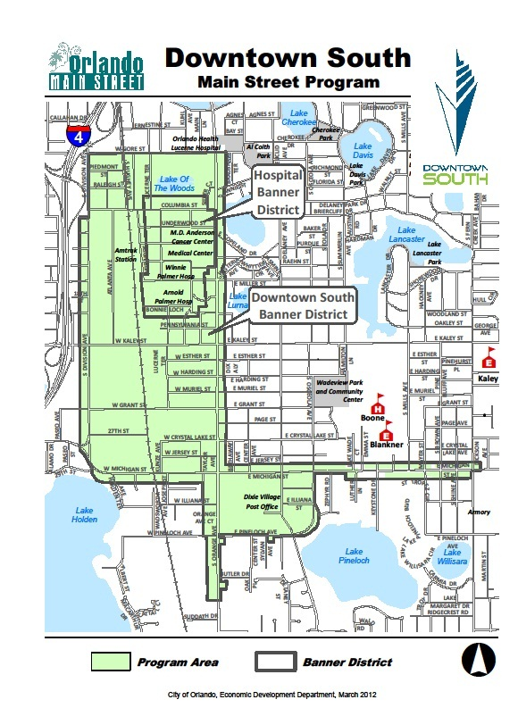
Attachment A
NID Map

