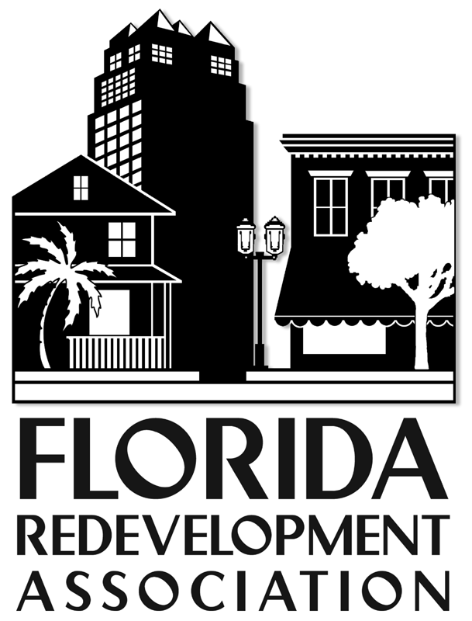

Annual Conference
Sponsor
Information and Forms

October 21-23, 2015
www.redevelopment.net

Please fill out the applicable forms to become an FRA 2014 annual conference
Sponsor. Thank you for your support!

Included in this kit are:

*Sponsorship Form
*List of Contribution Categories and Benefits

If you have questions, please feel free to contact us:

Carol Westmoreland cwestmoreland@flcities.com
Florida Redevelopment Association
P.O. Box 1757 • Tallahassee, FL 32302 • (850) 222-9684 • FAX (850) 222-3806
www.redevelopment.net

Sponsorship Form
2015 Annual Conference
October 21-23, 2015
Hilton Downtown Tampa

Sponsorship packages are designed to offer something for every sized company. In addition, individual sponsorships are available (see the list on the attached page). If you are selecting a sponsorship option that includes an exhibit booth, please also complete the “Exhibitor Agreement”.

Company/Organization:

___________________________________________________________________________________________________
(Please PRINT OR TYPE exactly as name should appear in program and on signage.)

Contact Name ________________________________Title_____________________________________________

Address ____________________________________City __________________State ____ Zip______________
_
Phone_______________________FAX___________________EMAIL___________________________________

Authorized Signature____________________________________________________Date___________________

Program Listing - If you are not taking a booth, please summarize the products/ services you provide (10 words)

_________________________________________________________________________________________________

On-Site Representatives: IF the package chosen includes registration(s), please send the names and titles and locations of each person registered on the “Name Badge Order Form”. FRA must be notified by October 9 of name changes or additions to ensure the availability of badges.

Sponsorship Type: Package #_____ Best Book Ad ____ Tour____ Break ____Gold ____Keynote____ Event________

Amount Enclosed: $ ______________ Payment Method:

❑ Check (payable to Florida Redevelopment Association)  Visa  MasterCard

Card # ____________________________________ Exp ___/___Cardholder Phone ____________________________

Cardholder Name _______________________________________________________________________________

Cardholder Signature _____________________________________________________________________________

Billing Address: ______________________________________________________________________________________

Return completed forms to: Florida Redevelopment Association Attention: Melanie Howe
P. O. Box 1757, Tallahassee, FL 32302, (850) 222-9684, Fax (850) 222-3806 mhowe@flcities.com

For FRA Use Only: Amount Paid $____________ Check # __________ Date _______

Confirmation Mailed: __________________ Initialed: _____________

SPONSORSHIP CATEGORIES/PACKAGES
October 21-23, 2015
Hilton Downtown Tampa
www.redevelopment.net

PACKAGE I
Capital Projects Book (Statewide)
2 feature articles in e-newsletter
10 posts on FRA social media
Cover logo on “Best Book”*
Exhibit booth at conference*
Sponsor listing in FRA publications
Exclusive Session sponsorship at conference*
Annual membership (includes directory)
2 conference registrations
Online Business Directory Listing
Two tickets to Project Connections reception
(45% discount over individual rates)
Total .......................................$5,500

PACKAGE II
Capital Projects (Statewide)
1 conference registration
1 feature article in e-newsletter
5 posts on FRA social media
“Best Book” half-page listing
Exhibit booth at conference*
Sponsor listing in FRA publications
FRA Membership Directory
Break sponsorship at conference
Online Business Directory Listing
Two tickets to Project Connections reception
(30% discount over individual rates)
Total .......................................$3,500

PACKAGE III
List of Capital Projects (Statewide)
“Best Book” quarter-page listing
Exhibit booth at conference*
FRA Membership Directory
Online Business Directory Listing
Sponsor Listing in FRA publications
One Ticket to Project Connections reception
30% discount over individual rates)
Total .......................................$2,500

PACKAGE IV
List of Capital Projects Statewide
Exhibit booth at conference*
FRA Membership Directory
Online Business Directory Listing
Sponsor Listing in FRA publications
One ticket to Project Connections reception
(40% discount over individual rates)
Total .......................................$1,500

OTHER SPONSORSHIPS***
Exclusive Event Sponsor… $3,000
Exclusive Keynote Sponsor…$2,500
Exclusive Session Sponsor $1,500
Tour/Break Sponsor…………$ 500**
4-color Awards Book listing $1,000**

NOTE: There may be more than one sponsor for
an event/session. However, all include:
Statewide Capital Improvement Projects List
Program recognition by category
Signage and recognition at event if applicable
One copy of FRA Membership Directory
1-3 Exhibit Hall passes for receptions/meal functions

*Based on availability. To receive an exhibit booth, exhibitor agreement must be completed along with sponsorship form.

**does not include any exhibit hall badges

*** NOT SEEING WHAT SUITS YOUR
NEEDS? LET US DESIGN A PACKAGE FOR YOU….Contact: Carol Westmoreland
850-701-3608 or cwestmoreland@flcities.com

Name Badge Order Form
(If Registering for the Annual Conference)
October 21-23, 2015
Hilton Miami Downtown

Number of badges allowed: Our 4-line badges include:
Exhibitor: 2 Badges First Name/Nickname
Sponsor $1,500 to $2,500: 2 Badges Full Name
Sponsor up to $5,000 3 Badges Company Name
Company Location*
*Title may be substituted for location

(Please Print Clearly)
Company/Organization:

______________________________________________________________

1. _____________________________________
_____________________________________
_____________________________________
_____________________________________

2. _____________________________________
_____________________________________
_____________________________________
_____________________________________

3. _____________________________________
_____________________________________
_____________________________________
_____________________________________

Return completed forms to:
Melanie Howe
(850) 222-9684, Fax (850) 222-3806 mhowe@flcities.com

P. O. Box 1757, Tallahassee, FL 32302

In order to be included in the conference program listing of sponsors please return your completed form to the FAX number, mail or e-mail above no later than October 9, 2015.

