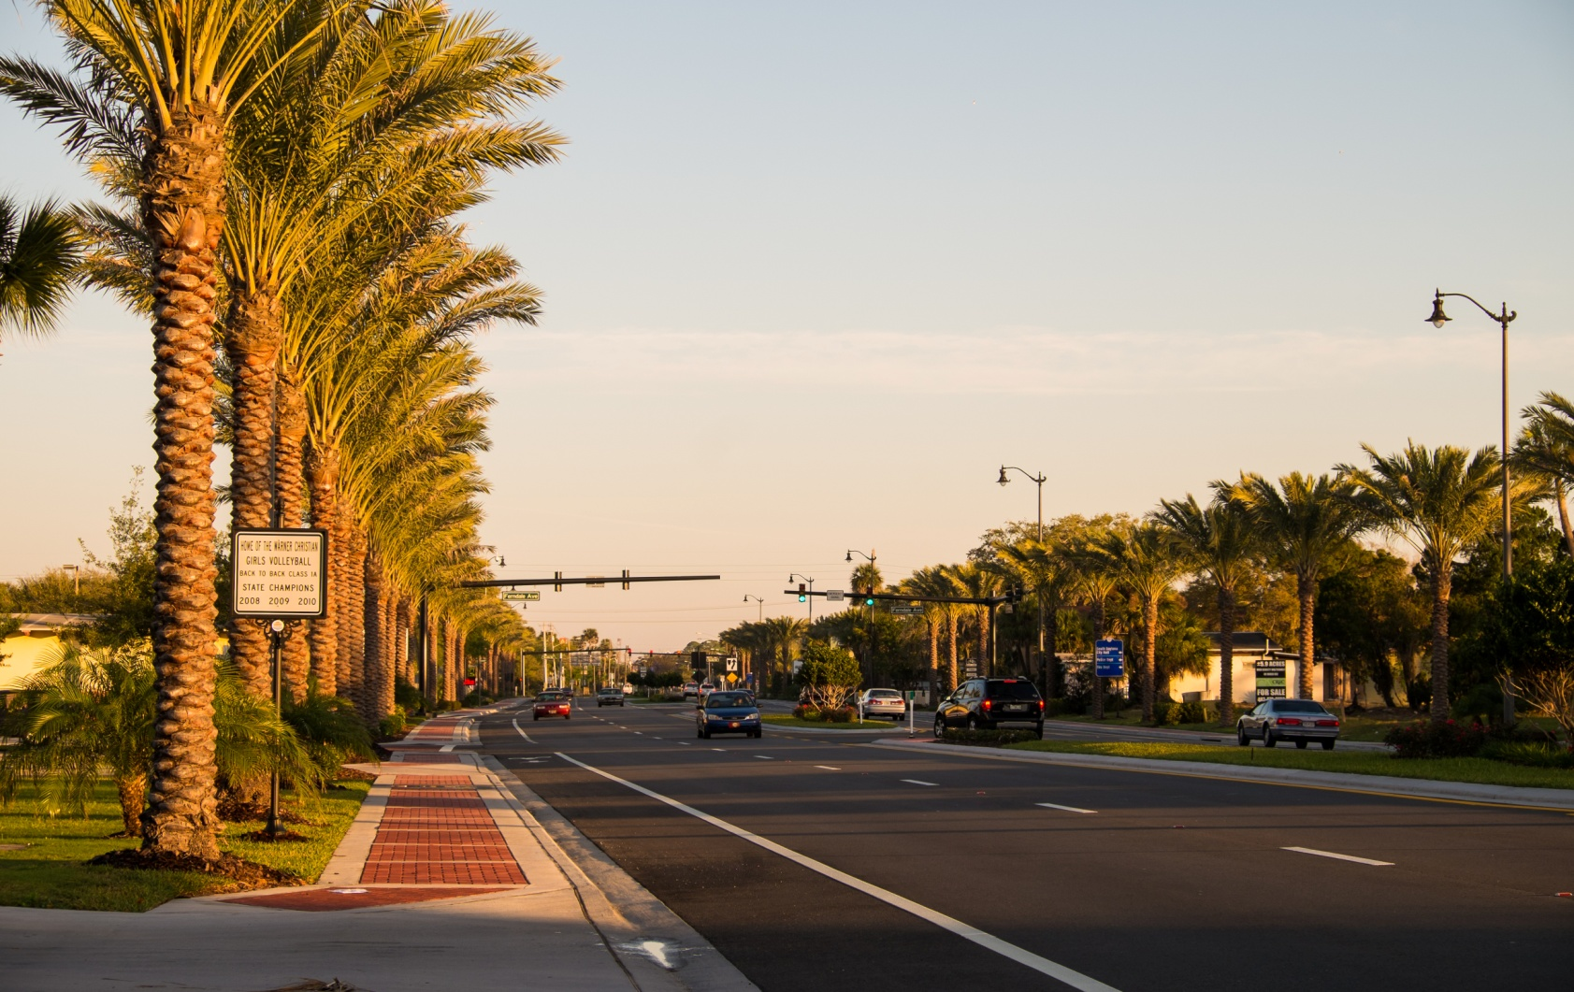

|  |  |  |  |
| --- | --- | --- | --- |
| **Streetscape Project Transforms Business Corridor**  The City of South Daytona completed the first section (both Phases I and II) of their US1 Streetscape project in January 2013. This project transcends a simple beautification project by incorporating aesthetic, safety and sustainability features into its design. Innovative project elements are visually attractive while enhancing safety along the corridor including undergrounding of utilities, audible pedestrian signals, wider decorative sidewalks, marked bike lanes and bus pull-offs. The city incorporated sustainable elements into this project with the addition of LED streetlights, drought tolerant landscaping and reclaimed water lines in the median for city and business use. The impact on the community will be felt for generations and sets the standard for other capital projects in the region.   |  |  | | --- | --- | | **Phase I:** Undergrounding of utilities, installation of LED decorative street lights, mast arm signalization and reclaimed water lines.  Construction Costs: $9,180,569  LAP Funding (FDOT):  $286,000  City Funding:  $8,894,569  Project Start Date:  August 2010  Project Completed:  June 2011 | **Phase II:** Decorative sidewoaks, road resurfacing with new bike lanes, landscaping, new curbing and pedestrian signals.  Construction Costs: $4,769,381  LAP Funding (FDOT): $4,230,767  City Funding: $538,614  Project Start Date: March 2012  Project Completed: January 2013 |   City officials believe these enhancements will serve as an impetus for further improvements by the private sector, noting that some business owners have already painted their buildings in response to corridor upgrades. In addition, two vacant buildings have subsequently sold, with one already under renovation.  Another business owner reported that his tenant chose to lease space in the City because of the street improvements. The remaining two sections are slated to be completed over the next five years depending on the level of increment revenues and funding availability. |  |

|  |  |
| --- | --- |
| photo_33.jpg | photo_13.jpg |

