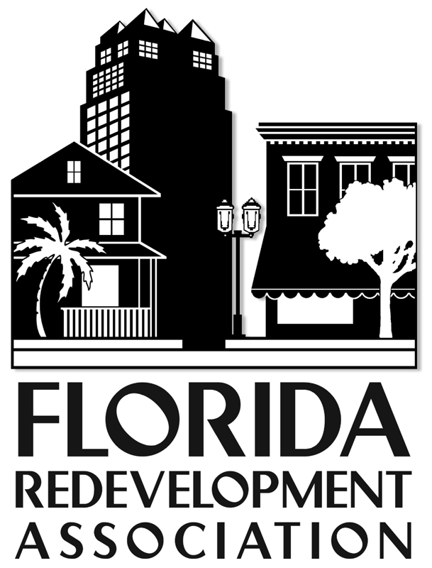

**SAMPLE NEWSPAPER ADVERTISEMENT REQUIRED BY LAW**

PUBLIC NOTICE

City/County of _________Community Redevelopment Agency (CRA) Report Available

In accordance with S. 163.356(3)(c), Florida Statutes, the City/County of _____________ CRA has developed the annual report of its activities for the preceding fiscal year, including a complete financial statement setting forth assets, liabilities, income, and operating expenses as of the end of fiscal year 2005. This report has been filed with the City/County Clerk and is available for inspection during business hours in the office of the Clerk, located at _______________________, phone number ______________. In addition, the report is available in the office of the CRA, located at __________________, phone number ______________.

For further information, contact the FRA at 850-222-9684, www.redevelopment.net.