**Florida Redevelopment Association**

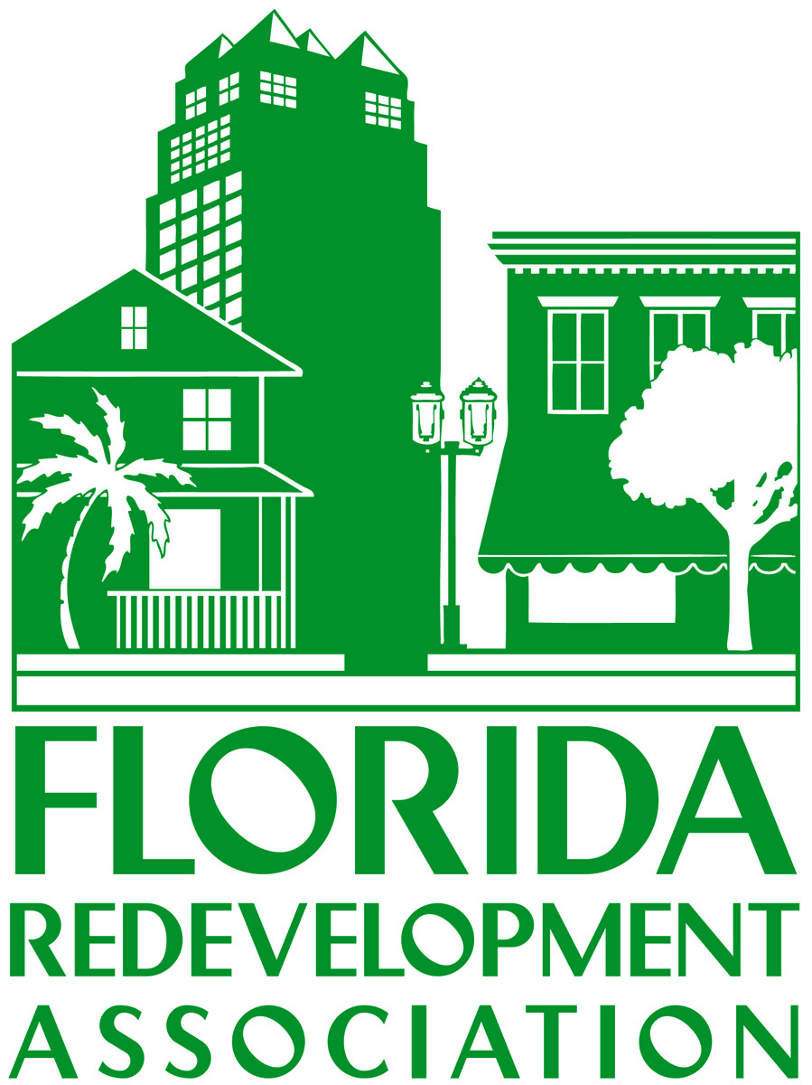

**South West Florida Regional Meeting**

**Tuesday, June 14, 2011**

11:30 a.m. – 1:30 p.m.

Mattison's Riverside Restaurant – Bradenton

***2011 Legislative Update and***

***Presentation by the Bradenton Central Community Redevelopment Agency***

***AGENDA***

11:30 Networking & Registration

12:00 Welcome

Introductions & Announcements

**Leigh Kellett Fletcher**, Attorney with Stearns Weaver Miller Weissler

Alhadeff & Sitterson, Tampa

12:15 Program

* *"2011 Growth Management Legislative Update "*

**Anne Pollack,** Attorney with Mechanik Nuccio Hearne & Wester, Tampa

* *"What Now? What Next? A New Vision for Economic Development*

*within CRAs "*

**Sherod Halliburton,** Executive Director of Central Community Redevelopment Agency in Bradenton

**Gypsy Gallardo,** CEO, Urban Market Ventures

1:15 Questions & Answers