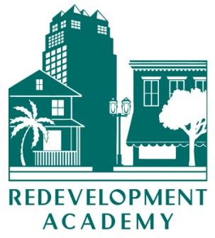

**FRA Academy Calendar**

**Core Courses**

***Operations and Capacity Building***

**When:** May 10, 2013 from 8:30 a.m. – 5:30 p.m.

**Where:** The Lou Frey Institute of Politics and Government

12443 Research Parkway  
OTC3 Suite 406  
Orlando FL, 32826  
(407) 823-4018

**Registration Deadline:** May 1, 2013

***Redevelopment 101***

**When:** June 5, 2013 from 8:30 a.m. – 5:30 p.m.

**Where:** Conference Room, FAU Research and Development Park

1501 SW FAU Research Park Blvd.  
Suite 200  
Deerfield Beach, FL, 33431  
(407) 823-4018

**Registration Deadline:** April 31, 2013

***Budgeting, Financing and Reporting***

**When:** June 6, 2013 from 8:30 a.m. – 5:30 p.m.

**Where:** Conference Room, FAU Research and Development Park

1501 SW FAU Research Park Blvd.  
Suite 200  
Deerfield Beach, FL, 33431  
(407) 823-4018

**Registration Deadline:** April 31, 2013

***Redevelopment 101***

**When:** October 29, 2013

**Where:** Annual Conference

**Non-core Courses**

***Incentives***

When: November 1, 2013

Where: Annual Conference

**NOTE:** application, registration and other information about the academy may be obtained at <http://redevelopment.net/about/redevelopment-academy/>. If you have questions, please contact Carol Westmoreland at 850-701-3608 or cwestmoreland@flcities.com.