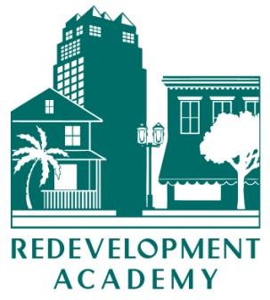

**CALENDAR 2013**

**CORE COURSES**

***Redevelopment 101***

**Deerfield Beach       June 5, 2013**

**Tampa     October 29, 2013 (Annual Conference)**

***Budgeting, Funding and Reporting***

**Deerfield Beach       June 6, 2013**

***Operations and Capacity Building***

**Orlando      May 10, 2013**

**NON-CORE COURSES**

***Incentives***

**Tampa       Nov 1, 2013 (Annual Conference)**

**NOTE: application, registration and other information about the academy may be obtained at** [**http://redevelopment.net/about/redevelopment-academy/**](http://redevelopment.net/about/redevelopment-academy/)**. If you have questions, please contact**

**Carol Westmoreland at 850-701-3608 or cwestmoreland@flcities.com.**