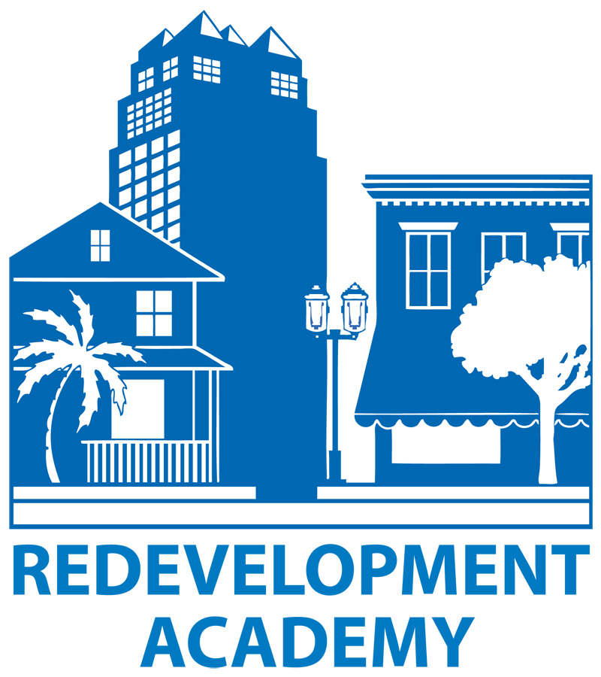

**2013-14 Academy Course Schedule**

**Operations & Capacity Building January 31, 2014 Lou Frey Institute, UCF Orlando**

**\*9:00 a.m. - 4:00 p.m.**

**Redevelopment Incentives May 22, 2014 RERC/GAI Offices, Downtown Orlando**

**\*9:00 a.m. - 4:00 p.m.**

**Budgeting, Financing & Reporting July 11, 2014 UCF Orlando**

**\*9:00 a.m. - 4:00 p.m.**

**Redevelopment 101 October 2014 Annual Conference - S. Florida TBA *9:00 a.m. – 4:00 p.m.**

**Capitol Program Management* October 2014 Annual Conference – S. Florida TBA**

**\*9:00 a.m. - 4:00 p.m.**

*Registration begins at 8:30. We ask that you plan to stay onsite for lunch, which is brown bag or an additional charge.