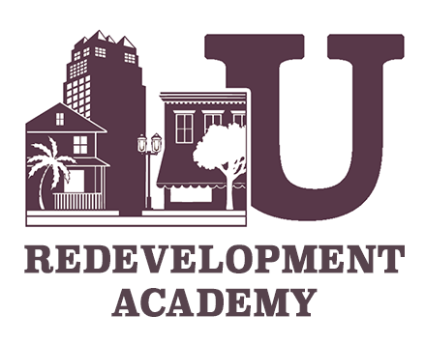

**C:\Users\jpiland\AppData\Local\Microsoft\Windows\Temporary Internet Files\Content.Outlook\RJHFGKS2\FRA-Certification.jpg**

**2014 Academy Course Schedule**

**Operations & Capacity Building January 31, 2014 Lou Frey Institute, UCF Orlando**

**\*9:00 a.m. - 4:00 p.m.**

**Redevelopment Incentives May 22, 2014 RERC/GAI Offices, Downtown Orlando**

**\*9:00 a.m. - 4:00 p.m.**

**Budgeting, Funding & Reporting July 11, 2014 RERC/GAI Offices, Downtown Orlando**

**\*9:00 a.m. - 4:00 p.m.**

**Redevelopment 101 October 7, 2014 Miami Hilton Downtown *9:00 a.m. – 4:00 p.m.**

**Capital Project Management October 11, 2014 Miami Hilton Downtown**

**\*9:00 a.m. - 4:00 p.m.**

***\*Course registration begins at 8:30 a.m. Beverages, refreshments and lunch are included.***

***Please note: On-site registrations will not be available due to the fact that course materials are sent out 14 days prior to each scheduled course. Registration/application must be received prior to each course registration deadline.***