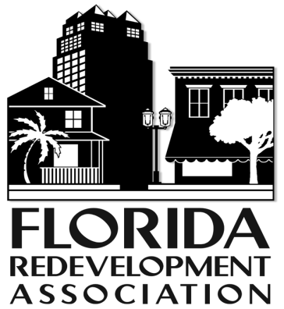
NEWS RELEASE

301 S. Bronough Street, Suite 300
Tallahassee, Florida 32302-1757
(850) 701-3609 Fax (850) 222-3806

www.redevelopment.net

FOR IMMEDIATE RELEASE: CONTACT: Carol Westmoreland, Executive Director
October 22, 2013 cwestmoreland@flcities.com or (850) 701-3608

TAMPA HOSTS REDEVELOPMENT RED CARPET EVENTS

The spotlight will be on Tampa during the annual conference, October 30 through November 1 downtown.

The Florida Redevelopment Association (FRA) will honor redevelopment programs from all over the state on a “red carpet”, October 31, at the Waterside Marriott Hotel. The outstanding redevelopment achievements in over ten categories will be recognized in conjunction with the FRA Annual Conference. All of the entries embody the spirit of successful community redevelopment and revitalization. “The FRA annual awards program brings statewide recognition to our members and their successful revitalization efforts,” said Steve Lindorff, FRA President. “Progress made today will sustain new growth and redevelopment for our communities, and we are very proud of these efforts.”

Also recognized during the conference October 30 and November 1 will be several tours of Tampa redevelopment projects: Tampa’s Urban Center, the Tampa Theatre and Performing Arts Center, the InVision East/WestTampa project, and the Tampa Heights Garden. These tours will highlight the new things happening in redevelopment in Tampa, as recognized by the FRA. Tampa’s urban areas have been blossoming for years now, said Carol Westmoreland, Executive Director of the FRA, but now we have an opportunity to show them off to people from all over the state.

If you are interested in the conference or signing up for a tour, visit www.redevelopment.net. The conference will be attended by private, public and non-profit stakeholders in the revitalization of downtown Tampa.

Founded in 1974, the FRA is a not-for-profit organization dedicated to assisting Florida professionals and volunteers in community revitalization efforts. With its mission of “transforming spaces, revitalizing places,” FRA is committed to providing a forum for its more than 300 members to share knowledge and common experiences regarding revitalization opportunities and issues. FRA advocates for quality urban economic development and urban infill, and serves as a statewide clearinghouse for redevelopment information.

# # #

