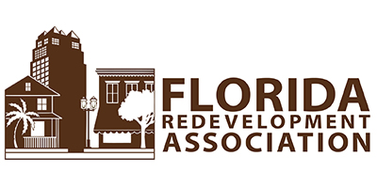
2019 ANNUAL CONFERENCE SESSION SUBMITTAL FORM
OCTOBER 16-18, 2019
TAMPA DOWNTOWN HILTON
DEADLINE FOR SUBMITTAL JANUARY 31, 2019
- TOPIC TITLE

________________________________________________________________________________________

- SESSION SUMMARY FOR PROGRAM (50 WORDS):

- NAMES AND AFFILIATIONS OF SPEAKERS (THREE ONLY)

- KEYNOTER SUGGESTION ______________________________________________________________________________________________________________________________________________________________________________________
___________________________________________________________________________________________

Without the speaker names and affiliation, the submittal will not be considered. Feel free to submit additional information on separate pages if desired. FILL OUT ONLINE, FAX, MAIL OR EMAIL this form and attachments to: cwestmoreland@flcities.com; 850-570-7206, PO BOX 1757 Tallahassee, FL 32302-1757; or FAX 850-222-3806. THANK YOU!

