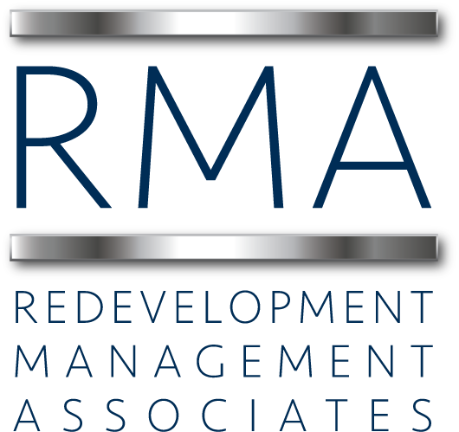

Urban Design & Project Manager Annual Salary: $45,000 – 60,000

Position Summary (Major Job Duties)
Responsible for managing projects in Community Redevelopment Agency (“CRA”) areas with an emphasis on urban design and planning, site planning, pre-construction services, zoning and land use application and overall project management. This position requires leadership qualities to manage and oversee multiple redevelopment projects and sub-consultants.
Duties and Responsibilities
- Assists in overall site planning and design and redevelopment activity related to housing, commercial redevelopment, and public space in multiple CRA distressed areas.
- Responsible for managing projects; ensuring redevelopment activity is in compliance with the comprehensive plan, zoning code and other regulations.
- Assists in writing new land use and form based zoning regulations, when needed, to encourage smart growth practices.
- Coordinates with City planning staff on proposed land use and zoning code changes.
- Assists in the planning and organization of design charrettes.
- Assists in the production of area wide design studies and reports.
- Interacts with community groups, residents and business owners in coordination and communication with City staff, elected officials and other public entities.
- Responsible for preparing agenda items for presentation during Commission, CRA Board meetings and other Boards and groups.
- Responsible for coordinating meetings and overall coordination and communication of activities with the public.
- Works with private development community, business owners and residents on site planning, zoning, platting, variances, incentives and other regulatory issues associated with the improvement or development of parcels within the redevelopment districts.
- Coordinates and manages consultants related to design, development, planning, right of way plans, master plans, land use plans and other planning activities on specific projects.
- Performs related duties as assigned.
- Assists in determining the level of public participation in real estate projects and follows the guidelines approved by the CRA Board.
Qualifications (Education, work experience, special requirements)
The candidate must possess a (4) year college degree from an accredited college or university with a major in Urban Design/Planning, or other related field. The candidate must have at least (2) years working in the public or private sector with experience in planning, architecture, neighborhood revitalization and/or economic development, or any equivalent combination of training and experience. The candidate must be a good public speaker and an excellent writer. Candidate could possess a state license in at least one of the fields of real estate brokerage, construction, architecture or other related field. Certification by trade associations exemplifying additional education is a plus, such as Florida Redevelopment Association, International Economic Development Association, International Downtown Association, International Council of Shopping Centers, or other related fields.

Physical Requirements and Work Environment
Performs various responsibilities, usually under direct supervision by the supervisor. However, the position will require working with a team of professionals who take on their own assignments but also share assignments with other project managers, supervisors and/or Executive Directors. Interprets departmental operations, policies, and procedures and disseminates relevant information. Composes a variety of correspondence, especially to the public. Establishes and maintains a variety of complex records and reports. Computes and compiles data. Sets up and maintains files. Schedules meetings. Refers callers to other employees, officials, consultants, or departments as needed. Observes conditions in the community, speaks with community leaders, takes photographs and posts notices.

Response
Email your letter of interest, resume and samples of work or portfolio to: info@rma.us.com
RMA
Please find information on the company at: www.rma.us.com

